

Pinellas County CADD Standards Manual for Survey and Civil Engineering

July 2025
Version 1.0

Table of Contents

Introduction 5
Purpose 5
Scope 5
General 5
Pinellas County Kit 6
Release Notes 6
AutoCAD Standards 7
Pinellas County Standard Template Files 7
Layers 7
AutoCAD Styles 8
Fonts 9
Linetypes 9
Line Weight 10
Plotting with AutoCAD Civil 3D 11
CAD Standards Checker 12
Civil 3D Standards 14
Civil 3D Objects 14
Starting Civil 3D 14
Civil 3D Projects 14
Civil 3D Drawing Creation 18
Standard File Names 19
Survey Drawing File Naming Conventions 20
Engineering Drawing File Naming Conventions 25
Civil 3D Workflows and Drawing Combinations 27
Sheet Set Manager 42
Data Shortcuts 43
Pinellas County Ribbon Tab 44
Survey & Mapping 48
Points 48
Point Format 48
Point Groups 48
Point Label Styles 49
Symbology and Description Keys 49
Figure Prefix Database 56
Linework Codesets 59
Graphic Symbols 61
Importing ASCII Files 61
Alignments 62
Digital Terrain Models (Surfaces) 63
Survey Title Blocks 66
Additional Survey Process Information 67
Civil Engineering 68
Points 68
Point Format 68
Point Label Styles 69
Alignments 69
Digital Terrain Models (Surfaces) 71
Profiles 73
Corridors 75
Cross-Sections 76
Pipes 77
Plans Production 80
Quantity Take-Off 80
Symbology 82
Standard CADD Layers 84
Layer Prefix and Suffix Descriptions 84
Standard Layers 84
Digital Delivery 92
General 92
Signing and Sealing Contract Plans 92
Manual Signing and Sealing 93
Digital Signing and Sealing 93
Single Digital Signature 94
Multiple Digital Signature 95
Signing and Sealing Revisions 95
Foreign Plan Sheets 96

Introduction

Purpose
The electronic files created during the process of developing a Computer Aided Design and Drafting (CADD) project for Pinellas County (from here on referred to as “PC”) are to be shared and referenced by many different individuals and must satisfy various needs. The electronic files must be shareable in a format that most, if not all, parties can utilize. Therefore, CADD processes must be established for disciplines that share in the CADD development workflow. This CADD Standards Manual outlines the required standards, conventions, and formats necessary to ensure the most usable CADD data set to the foreseeable customers of the CADD data, while providing the producer / developer of the CADD data information necessary to accomplish the task.

Scope
This CADD Standards Manual sets forth supplemental guidelines to the Pinellas County – CADD Project Administration Manual. The material presented within this guideline will be monitored as a critical requirement under the CADD Quality Assurance plan. This document is written for CADD users producing plans and maps for PC. It provides the guidelines to produce electronic CADD files according to PC CADD standards in conjunction with PC CADD software.

General
Chapter 334 of the Florida Statues, known as the Florida Transportation Code, establishes the responsibilities of the State, Counties, and Municipalities for the planning and development of the transportation systems serving the people of Florida, with the objective of assuring development of an integrated, balanced statewide system. The Code's purpose is to protect the safety and general welfare of the people of the State and to preserve and improve all transportation facilities in Florida. Under Section 334.044(2), the Code sets forth the powers and duties of PC in conjunction with the Department of Transportation to develop and adopt uniform minimum standards and criteria for the design, construction, maintenance, and operation of public roads.
The guidelines in this PC CADD Standards Manual and the FDOT Production Criteria represent minimum requirements that must be met for the development PC CADD projects. While the guidelines contained in this writing provide a basis for uniform CADD practice for PC projects, precise rules that would apply to all possible situations that may arise are impossible to give. Situations will exist where these standards will not apply. If variances from the PC CADD Project Administration Manual or PC CADD Standards Manual are necessary for a project, they must be approved in writing by the Project Manager and documented in the Project Journal file as defined herein.

Pinellas County Kit
PC utilizes Autodesk software as a standard for all civil engineering and land surveying projects. PC currently uses the following CADD software products:
- AutoCAD Civil 3D
- AutoCAD Raster Design

To help increase, enforce, and maintain consistency of the drawings created for PC, the Pinellas County Kit for Civil 3D 2025 has been created and is required for all projects. Leveraging components of the FDOT State Kit, the PC Kit includes Civil 3D content necessary to complete projects for PC. The following custom content is included in the PC Kit for Civil 3D:
- Drawing templates containing Civil 3D styles
- Plans production templates
- Project templates
- Sheet Set Manager template
- Title blocks
- Pipe’s catalog
- Quantity take-off pay items
- PC ribbon tab and workspace
- Design Center content
- Autodesk Batch Standards Checker files
All new projects must use the latest version of the PC Kit. The kit is available on the Pinellas County website. Please make sure you are using the latest version of the kit prior to starting any PC project.

Release Notes

The Pinellas County Kit for Civil 3D 2025 is designed to be centralized on a network share and has several dependencies to function properly. For detailed release and installation information, please view the release notes.

AutoCAD Standards

Pinellas County Standard Template Files
Included with the PC Kit for Civil 3D are 3 drawing template files that have been configured with PC standards. These templates should be used when working on PC projects:

Template File Name | Description
PC2025.dwt | This is the main template file that should be used when starting any new Engineering or Surveying drawing.
PCPlanProduction.dwt | This template file should only be used when using the plans production tools contained within Civil 3D.
PCTitleBlocks.dwt | This file contains all the PC standard title blocks. This file should not be used directly! Instead, use the insert title block routine built into the Pinellas County ribbon tab.

Layers
All PC standard layers are included in the PC2025.dwt drawing template. To help navigate through the layer list, several layer filters have been created depending on the situation:

Layer Filter | Description
All Used Layers | All layers that contain entities in the drawing
PC C3D Object | Civil 3D object layers
PC Engineering | Layer filter to isolate proposed layers
PC Survey | Layer filter to isolate existing layers
PC Production-non-util | Layer filter used in conjunction with the invert filter option to isolate non-utility layers

AutoCAD Styles
Text Styles

All text in an AutoCAD drawing has a text style associated with it. When you enter text, AutoCAD uses the current text style, which sets the font, size, angle, orientation, and other text characteristics.
PC has standardized on using annotative text styles for placing text inside of drawings. Annotative text allows the ability to automatically size the model space text height based on the plotted height of the text and the current annotation scale.

Text Style | Font | Plotted Height | Description
PC-Sv 0.08 | Simplex | 0.08” | Existing Text – 0.08” plotted
PC-Sv 0.10 | Simplex | 0.10” | Existing Text – 0.10” plotted
PC-Sv 0.15 | romand | 0.15” | Existing Text – 0.15” plotted
PC-Sv 0.20 | romand | 0.20” | Existing Text – 0.20” plotted
PC-Sv Romand | romand | 0.12” | Existing Text – 0.12” plotted
PC-Eng | Simplex | 0.12” | Proposed Text – 0.12” plotted
PC-Eng 0.15 | Simplex | 0.15” | Proposed Text – 0.15” plotted
PC-Eng 0.20 | romand | 0.20” | Proposed Text – 0.20” plotted
PC-Eng 0.25 | romand | 0.25” | Proposed Text – 0.25” plotted

Dimension Styles

In the PC standard template file(s), you will be able to select the dimension style based on the final output scale of your drawing. PC assigns the default “PC-Proposed” style to dimensions until you set another style as current. Dimension styles are set to be annotative and will size in model space to reflect the current annotation scale.

Unless you create a separate style for leaders, or change leader properties using the Properties window, leader lines have the same properties as dimension lines.

Dimension Style | Description
PC-Sv-Existing | Used for dimensioning of existing objects – Plotted text height is 0.08”
PC-Eng-ByLayer | Used for dimensioning of proposed objects – Plotted text height is 0.15”

Fonts
Fonts define the shapes of the text characters that make up each character set. In AutoCAD, you can use TrueType fonts in addition to the AutoCAD compiled shape (SHX) fonts.

The PC Standard for all Labels is “Simplex.shx” with a height set by the output scale of the drawing.

Linetypes
Linetype definition files define AutoCAD linetypes. These files have the extension .lin. AutoCAD linetypes are composed of a series of dots and dashes separated by spaces and can contain embedded shape and text objects. The default linetype file is acad.lin. You can print this file to better understand how to construct linetypes.
Linetypes that are composed of only dots, dashes, and spaces are considered simple linetypes. Linetypes that contain embedded shape and text objects along with dots, dashes, and spaces are complex linetypes. Although AutoCAD handles these two types of linetypes similarly, their definitions are considerably different. Users are strongly discouraged from creating their own custom line styles; instead using the PC supplied standard line style files listed below:

L:\2025\Support\Linetypes\PinCo.lin

PC Custom Linetype Files
To use a linetype you must first load it into your drawing. A linetype definition must exist in an LIN library file before a linetype can be loaded into a drawing. If a new (non-standard) custom linestyle is developed by a user, those resource files must be delivered with the project. Users shall not modify the PC delivered standard custom line style files. You can assign a linetype to a layer, set the current linetype control for the new layer to be (BYLAYER). All newly created objects are drawn using the current linetype (except for text and inserted blocks).

Line Weight
Standard lineweights are defined in the PC standard layer tables as referenced from the standard layers section mentioned above. An AutoCAD standard lineweight table is listed below for reference purposes. Currently PC does not use lineweights as defined by the object’s layer, but instead references lineweight by color in the CTB (Color Table) file.

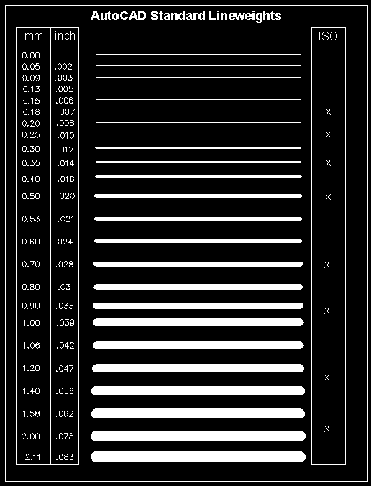

PC uses the standard color table within AutoCAD in the following fashion:

Colors 1-9,250-254 - Standard colors shared for both existing and proposed data representation

Colors 11-249 - (ODD numbered colors) Existing layers (Survey)

Colors 10-248 – (EVEN numbered colors) Proposed layers (Engineering)

Plotting with AutoCAD Civil 3D
Plots

Regarding the production of plots, all plots shall be to scale on the standard PC standard Layout tab sheet setup files applicable to the specific discipline and their applicable standards. In addition, the plots (hardcopy paper) shall contain a plot stamp with the following items:

Network drive path, file name, and date at the lower left-hand corner of the sheet.

For all PDF plots, the PDFSHX setting must be set to 0. If Civil 3D was started with the Icon, this will be automatic.

Plotter Configuration Files

The trend from Autodesk is to utilize the Microsoft plotter drivers as much as possible and therefore minimal PC3 files are being shipped with the PC Kit. Two PC3 files included with the kit are:

  - DWF6 ePlot.pc3
  - DWG to PDF.pc3

These files should be used to create DWF’s and PDF’s respectively.

Plot Borders

The following PC standard sheets have three plot borders, they are:

Actual Paper Size | Plot Size | Plotting Limits | Paper Size
22” x 36” | 22” x 34” | 33.94” x 21.94” | Custom
11” x 17” | 11” x 17” | 16.94” x 10.94” | ANSI B
8.5” x 11” | 8.5” x 11” | 10.50” x 8.00” | Letter

Plot Style Tables (*.ctb)
For color-dependent plot style tables, an object's color determines how it is plotted. These plot style table files have .ctb extensions. You cannot assign color-dependent plot styles directly to objects.
Instead, to control how an object is plotted, you change its color. For example, all objects assigned the color red in a drawing plot the same way.
PC has assigned color-dependent plot style tables (CTB’s) to layouts. Two CTB files are provided as part of the kit depending on the department:

- Engineering.ctb
- Survey.ctb

CAD Standards Checker
To help ensure adherence to the established standards, PC utilizes the CAD Standards Checker that is built into Civil 3D 2025 and has provided 3 DWS files that are to be used:
- Survey.dws
- SurveyToEngineering.dws
- Utilities.dws

These DWS files correlate to one of the 3-layer states included in the PC2025.dwt file.

The DWS files are found in the L:\2025\Data\LayerStandards folder

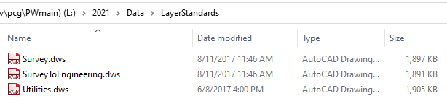

The first time the standards checker is run, a DWS file will need to be associated with the file. Choose the appropriate DWS file as noted above. Once associated, the utility will run and display a dialog box that shows the total number of errors in the drawing:

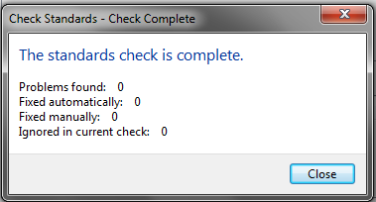

Production drawings should not contain any standards errors. Should the drawing contain standards errors, a dialog box will be displayed giving the user a chance to address each problem individually.

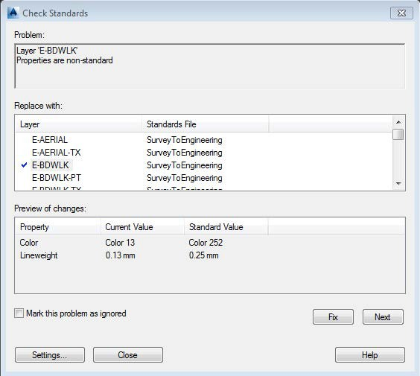

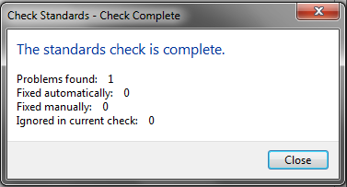

Civil 3D Standards

Civil 3D Objects
To ensure the integrity and continuity of an efficient workflow and design process throughout the survey, design, construction, and Building Information Modeling (BIM) processes, all PC projects shall require the use of Civil 3D objects.
The following design items must be created as Civil 3D objects and must be assigned PC object styles using the provided Civil 3D drawing template that is included with the PC Kit for Civil 3D:

- Points
- Survey Figures
- Corridors
- Parcels
- Pipe Networks
- Sections
- Surfaces
- Alignments
- Profiles

Starting Civil 3D
To ensure the PC environment is enabled when starting Civil 3D, it is important to launch the software using the supplied icon:

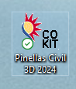

Civil 3D Projects
AutoCAD Civil 3D uses projects to manage and organize all the data for a job that you are working on. This data includes the drawing files, data shortcuts, and survey database. Each project will have its own unique directory path. Survey projects will continue to be named based on the SFN (Survey File Number
- F####) numbering convention. Engineering projects will be named based on the PC Project Identification Number (PID ****) as provided by OPUS.

To create a project in Civil 3D, right click on “Data Shortcuts” from the prospector tab and select “Set Working Folder…”. Make sure to use the designated division drive letter.

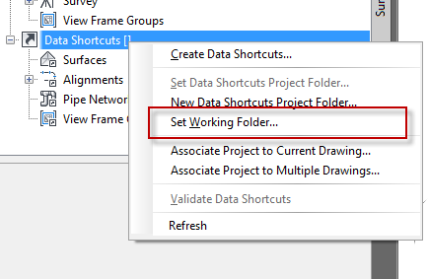

Next, right click on “Data Shortcuts” from the prospector tab and select “New Data Shortcuts Project Folder…”.

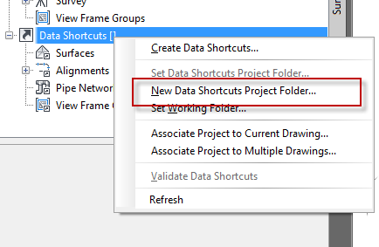

In the resulting dialog box, make sure that the working folder is set to the designated division drive letter. Give the project a name based on the SFN (F####) or the PID (****) number assigned to the project. Make sure that “Use project template” is selected and the appropriate project template is selected according to the project discipline.

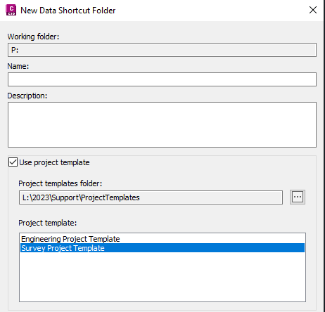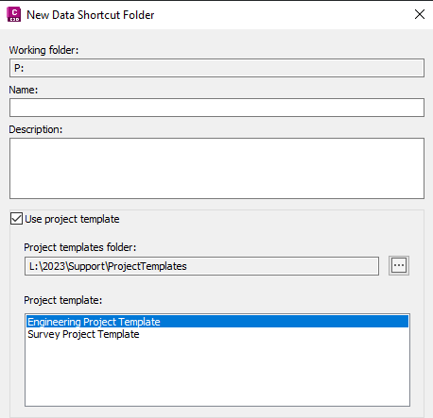

Once complete, the new project will be listed in prospector and the directory system will be created based on the applicable project template:

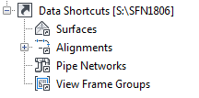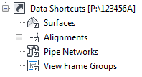

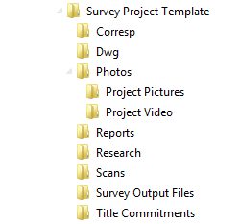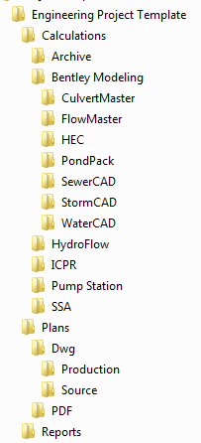

Civil 3D Drawing Creation
After launching Civil 3D using the included PC icon, the product is configured to automatically use the PC2025.dwt template file. There are buttons on the quick access bar as well as the PC ribbon tab that can be used to create additional drawings and will ensure the appropriate template containing the PC styles is used:

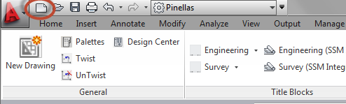

Or

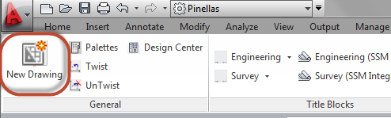

Standard File Names
The following file naming convention shall be used for all design files. The file naming convention as defined for each discipline shall be used in combination with the previously defined PC standard project directory structure. In the event a particular file type that is needed for the project is not addressed in this document, use the file naming convention as a template, or consult with the project manager to determine the proper file name and its parameters.
NOTE: Some overlap in project drawing creation is expected to occur depending upon the design group’s need for a multiple document environment. Whether or not this is the case, the original drawing and the sheets contained therein must reflect the tab (layout) series number naming convention proposed in the accompanying file naming tables.

Standard File name extensions
  - AutoCAD drawing file - .dwg
  - AutoCAD template file - .dwt
  - AutoCAD drawing exchange format - .dxf
  - AutoCAD drawing web format - .dwf
  - AutoCAD drawing standards format - .dws

Survey Drawing File Naming Conventions

The name for a standard survey or worksheet:

f<SFN number>-c3d-<version number>.dwg
Example: A standard survey for SFN 1800 that is created with Civil 3D version 2025 will have the name f1800-c3d-2025.dwg.
The layout tabs for a standard survey or worksheet:

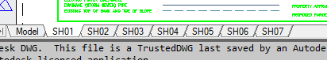

When a survey contains pipe networks, a second drawing should be created using the following naming convention.
f<SFN number>-pipes-c3d-<version number>.dwg
This drawing will contain no layout tabs. All work should be done in model space.

The name for a REVISED standard survey or worksheet:

f<SFN number>-c3d-<version number>-r#.dwg
“r#” represents the revision number.
Example: The first complete set of revisions to a standard survey for SFN 1800 that is created with Civil3D version 2025 will have the name f1800-c3d-2025-r1.dwg. This name will continue to be used throughout the mapping process until the survey is signed and sealed. Once signed and sealed, if a second revision is needed, the survey will have the extension “r2”.

The layout tabs for a REVISED standard survey or worksheet:

The name for a REVISED pipe network drawing:

f<SFN number>-pipes-c3d-<version number>-r#.dwg

The name for a standard sketch and description:

p<parcel number>-c3d-<version number>.dwg
Example: A standard sketch and description for parcel P100 that is created with Civil3D version 2025 will have the name p100-c3d-2025.dwg.
The layout tabs for a standard sketch and description:

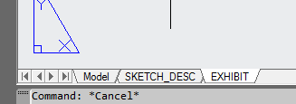

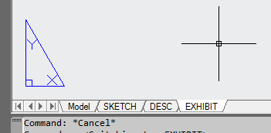

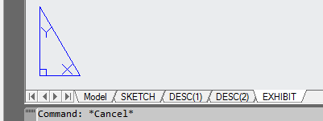

The name for a REVISED standard sketch and description:

p<parcel number>-c3d-<version number>-r#.dwg
“r#” represents the revision number.
Example: The first complete set of revisions to a standard sketch and description for parcel P100 created with Civil3D version 2025 will have the name p100-c3d-2025-r1.dwg. This name will continue to be used throughout the mapping process until the sketch and description is signed and sealed.
Once signed and sealed, if a second revision is needed, the sketch and description will have the extension “r2”.

The layout tabs for a REVISED standard sketch and description:

The name for a standard 8 ½ x 11 exhibit that accompanies a sketch and description:

A standard .dwg naming convention is not needed. The exhibit should be included as a layout tab in the sketch and description (see above).

The name for an 11 x 17 exhibit.

exhibit-<subject >-c3d-<version number>.dwg
Exhibits are created for various purposes and are not standard. The user should replace the <subject> field with a short abbreviation for the type of exhibit. The abbreviation is left to the user’s discretion.
Example: An exhibit prepared to accompany a title commitment would have the subject abbreviation “tc”, such as exhibit-tc-c3d-2025.dwg.
Example: An exhibit prepared to depict limits of multiple plats would have the subject abbreviation “plats”, such as exhibit-plats-c3d0-2025.

The layout tabs for an 11 x 17 exhibit.

The layout tabs for an 11 x 17 exhibit are also not standard. Try to hold one of the naming conventions for the layout tabs shown above if possible.

Engineering Drawing File Naming Conventions
Sheet Description | File Name
Key Sheet/Vicinity Map | ****-KEY.dwg
Quantities/ Summary of Pay Items | ****-QTY.dwg
General Notes/Legend | ****-GEN.dwg
Symbology/Linetypes | ****-SLL.dwg
Coordinate Geometry | ****-CG.dwg
Layout | ****-LAY.dwg
Drainage Map | ****-DRM.dwg
Typical Section | ****-TYP.dwg
Existing Structures/Demolition Plan | ****-DEMO.dwg
Plan / Profiles | ****-PLPR.dwg
Grading | ****-GRAD.dwg
Drainage Structure Sheets | ****-DRST.DWG
Cross Sections | ****-XS.dwg
Details, 01, 02, 03 … | ****-DTL01.dwg
Environmental | ****-ENV.dwg
Mitigation | ****-MIT.dwg
SWPPP | ****-SWPP.dwg
Erosion Control Plan/Notes | ****-EROS.dwg
Geotechnical | ****-GEO.dwg
Temporary Traffic Control Plans | ****-TTCP.dwg
Signing & Marking Plan | ****-SPM.dwg
Signalization Plan | ****-SIG.dwg
ATMS | ****-ATMS.dwg
Landscaping Plan | ****-LS.dwg
User Defined | ****-USER.dwg
Survey Drawing | F####-C3D-2025.dwg
Survey Pipes Drawing | F####-PIPES-C3D-2025.dwg
Engineering Survey Base Map | F####-BASE.dwg
PC - Utilities (WM, SS, FM, & RCWM) | ****-WM.dwg
 | ****-SS.dwg
 | ****-FM.dwg
 | ****-RCWM.dwg
 | ****-UTL.dwg
Other - Utilities | ****-UT-(owner).dwg
Utility Relocation | ****-URL.dwg
Corridor Model | ****-CORR.dwg
Storm Drainage | ****-STM.dwg
3D Presentation | ****-3DP.dwg
Sheet Index | ****-IND.dwg
Plan and Elevation | ****-PE.dwg
Bridge Hydraulic Recommendations | ****-BHR.dwg
Construction Sequence | ****-CS.dwg
Foundation Layout | ****-FDL.dwg
Superstructure Plan | ****-SUPL.dwg
Superstructure Details | ****-SUPDT.dwg
Finished Grade Elevations | ****-FGE.dwg
Endbent Plan | ****-EBPL.dwg
Endbent Details | ****-EBDT.dwg
Pier Plan / Elevation | ****-PPEPL.dwg
Pier Details | ****-PPEDT.dwg
Slope Protection Details | ****-SPDT.dwg
Finish Grade Elevations | ****-FGE.dwg
AASHTO Type (?) Beam - Standard Details - Index No. (?) | ****-BDT.dwg
AASHTO Type (?) Beam - Table of Beam Variables | ****-BV.dwg
Buildup Deflection Data Table for I-Beams Index No. S-900 | ****-BDD.dwg
Composite Elastomeric Bearing Pads - Index No. 501 | ****-CEBP.dwg
Approach Slabs - Geometric Layout | ****-ASGEO.dwg
Approach Slabs (Flexible Pavement Approaches) Index No. S-900 | ****-ASPVT.dwg
Retaining Wall General Notes | ****-RWGN.dwg
Retaining Wall Plan | ****-RWP.dwg
Retaining Wall Elevation | ****-RWE.dwg
Retaining Wall Details | ****-RWDT.dwg
Reinforcement Bar List | ****-RBL.dwg

NOTE:

**** = PID number

#### = SFN

Civil 3D Workflows and Drawing Combinations
While it is virtually impossible to describe every potential sheet necessary in a plan set, the following workflows describe common engineering and surveying tasks.

Survey – Topography

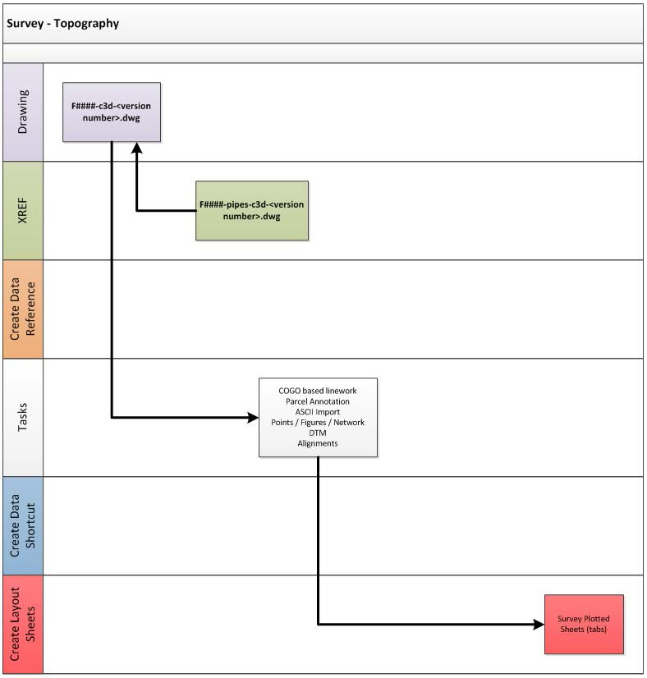

Survey – Existing Utilities

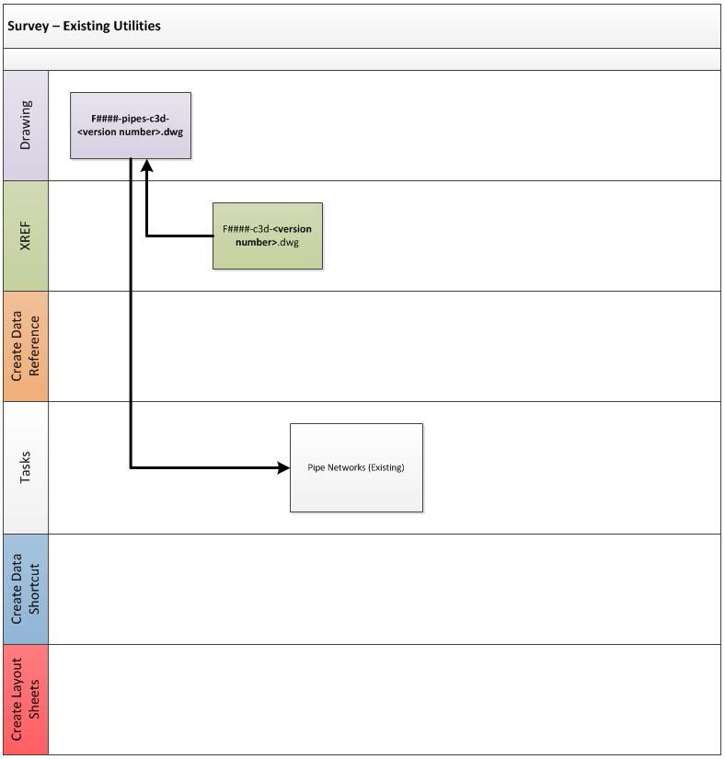

Survey Pipes to Engineering Pipes Drawing Setup

  - Set up project (see Civil 3D Standards Section)
  - Set up Sheet Set Manager (see Sheet Set Manager Section)
  - Save survey file F####-C3D-2025.DWG to the project Source directory
  - Save survey file F####-PIPES-C3D-2025.DWG to the project Source directory
  - Save copy of F####-PIPES-C3D-2025.DWG as F####-PIPES-BASE.DWG

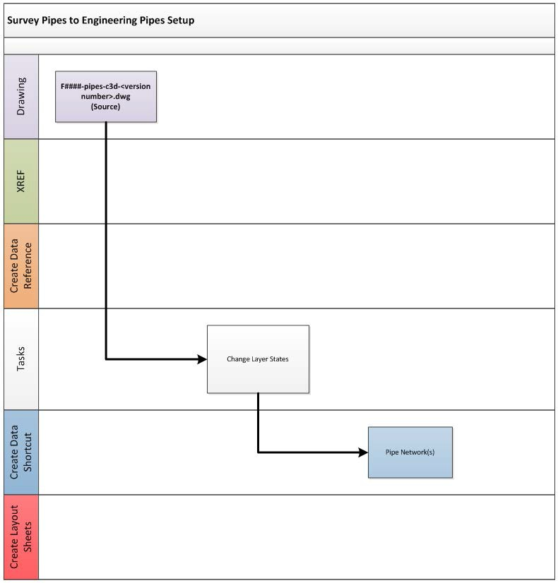

Survey to Engineering Drawing Setup
  - Save copy of survey file F####-C3D-2025.DWG as F####-BASE.DWG
  - XREF F####-PIPES-BASE.DWG into this drawing

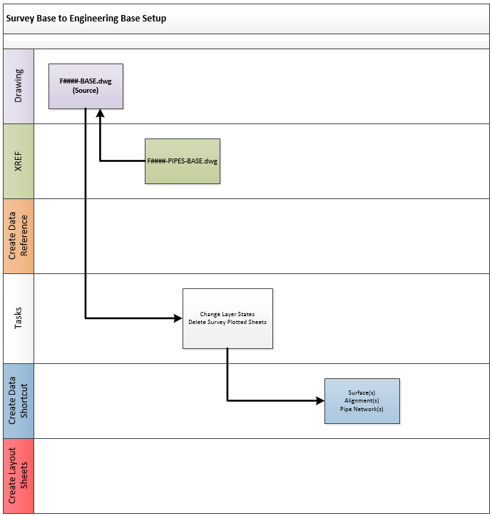

Layout

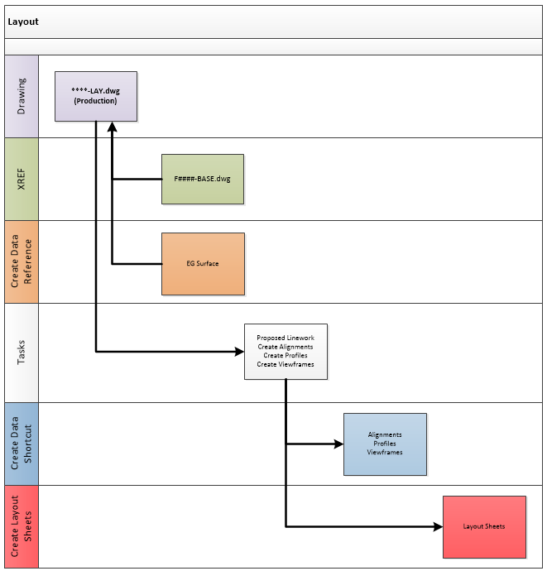

Drainage Map

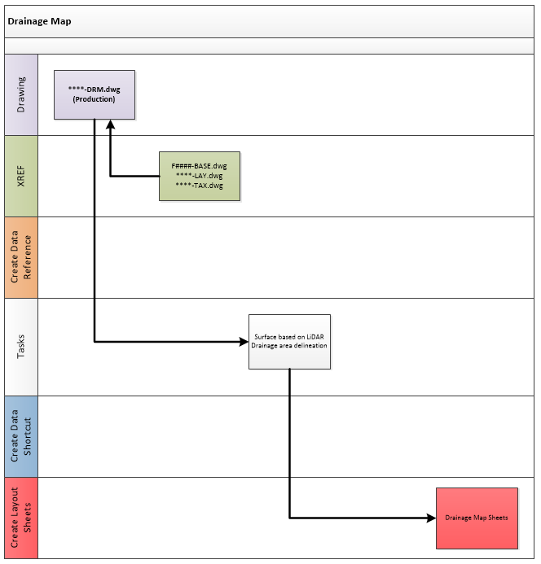

Corridor

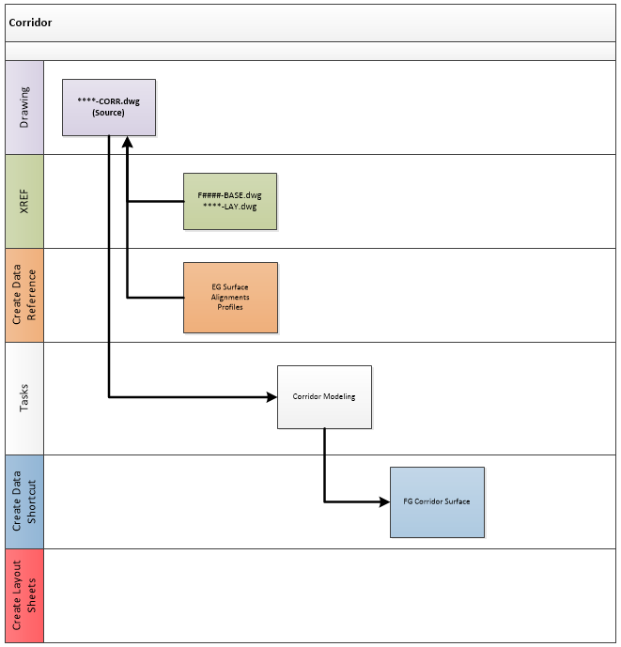

Cross Sections

  - Change the scale of the drawing equal to the desired scale of the cross sections prior to creating the cross sections.

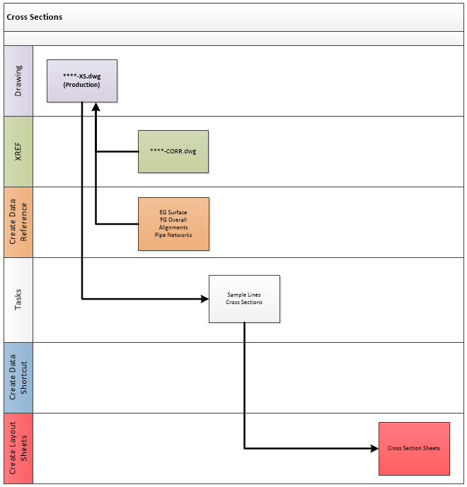

Storm Drainage

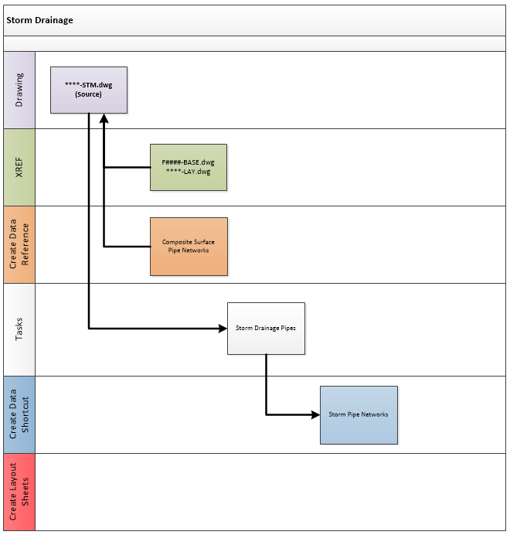

Grading

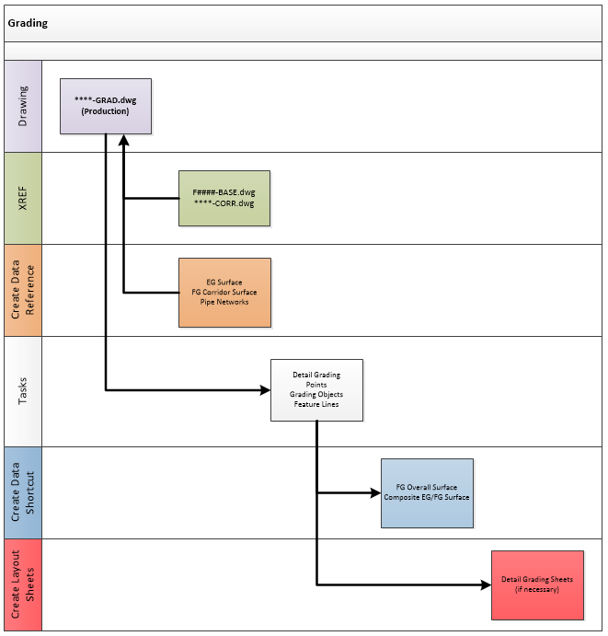

Utilities

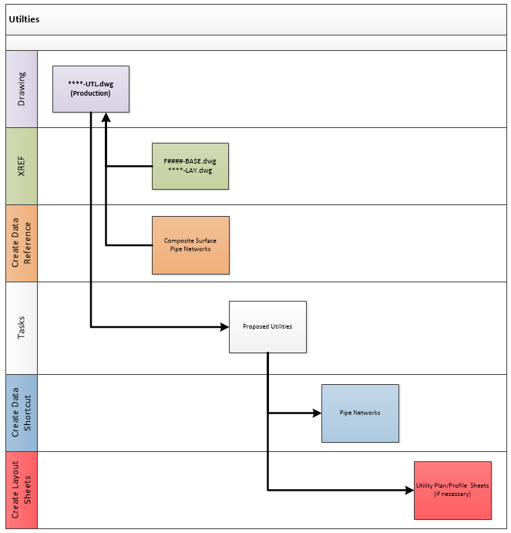

Drainage Structure

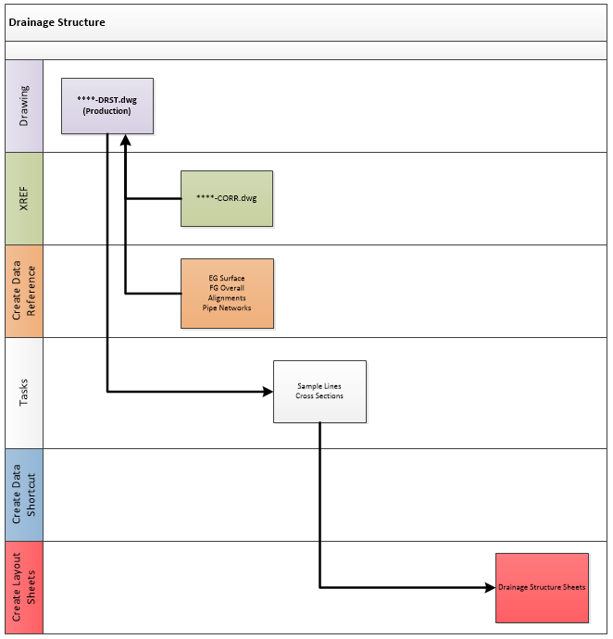

Plan / Profiles

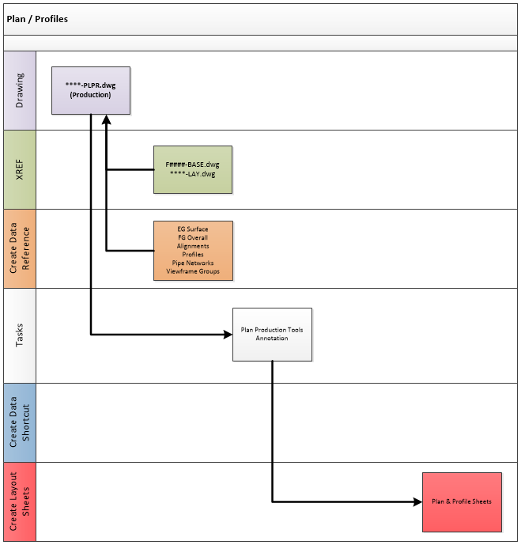

Demolition Plan

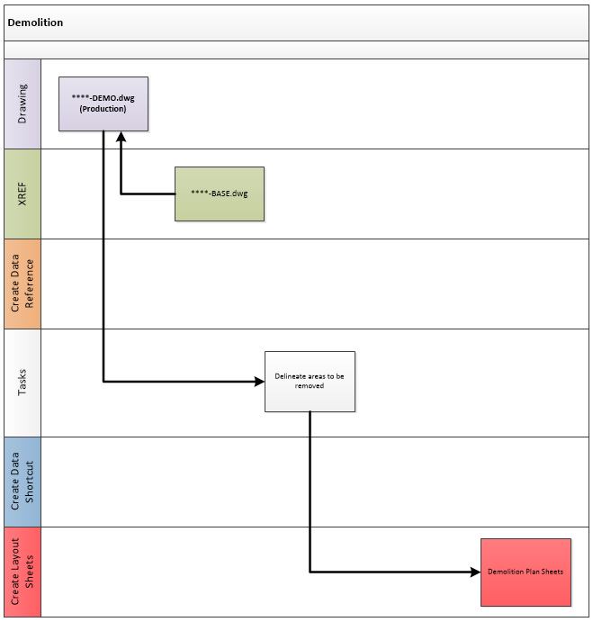

Sheet Set Manager
To help organize and plot drawings, sheet set manager has been implemented. A PC sample sheet set is included with the kit and should be used to create project sheet sets. Project based sheet sets only need to be created once per project and should be stored within the project directory structure.

The existing sheet set template can be found at: L:\2025\Support\SSM\Pinellas Sample.dst

Several PC title blocks have fields created that link with this sample sheet set. From the PC ribbon tab, any title blocks listed in the insert title block routine that have (SSM) at the end of the name are sheet set manager integrated.
Layout tabs created in the various design drawings can be added to the sheet set by dragging and dropping the layout tab in the applicable location on the sheet set.
A short video demonstrating how to create a new sheet set and add sheets can be found here.

The screen shots below show the customized fields in the sheets as well as the overall sheetset:

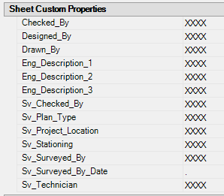 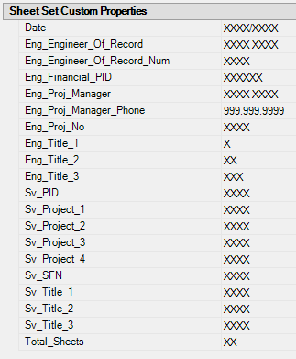An example of each title block demonstrating the location of the SSM fields can be found here.

Data Shortcuts
Data shortcuts will be used to share Civil 3D object data from one drawing within the project to another. Drawings should be kept small and combined as necessary based on the defined workflows to maintain performance within the application.
Once data shortcuts have been created, the source drawing should never be moved or renamed. Doing so will cause the shortcut to become broken.
A short video demonstrating how to fix a broken reference can be found here

Pinellas County Ribbon Tab

General Pane

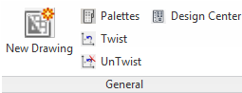

The new drawing icon should be used when creating new drawings from scratch to ensure the appropriate PC Kit template is being used.

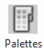 Icon toggles tool palettes on and off.
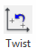 Routine to more quickly perform DVIEW Twist operations. 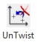 Routine to undo DVIEW Twist operations.
Opens Design Center so that you can insert items such as typical sections, standard symbology and other PC standard items.

Title Blocks Pane

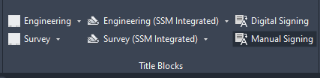

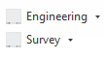The left two icons of this pane are used to insert PC standard title blocks into the current drawings. These title blocks do not include any sheet set manager integrated fields.

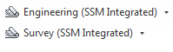The middle two icons of this pane are used to insert PC standard title blocks into the current drawings. These title blocks do include sheet set manager integrated fields. These title blocks should be used most of the time.

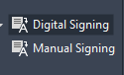 The right two icons of this pane are used to change the layer state of the drawing.

Survey Tools Pane

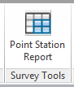

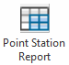This icon launches a custom application that creates a point report that includes alignment station and offset information.

Aerials Pane

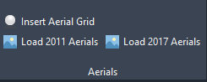

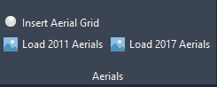These icons are used to create a WMS data connection to PC aerial photos. The WMS connection information is saved within the DWG file and is accessible outside the county. No additional software is required to use this functionality.

FDOT Tools Pane

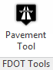

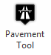This icon launches the FDOT pavement marking tool within the PC kit.
NOTE: This tool needs to be run from the FDOT kit first to setup the necessary files prior to using it from the Pinellas configuration.

Help Pane

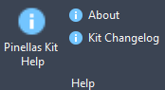

 Launches PC CAD standards manual.

Displays release notes about the version of the PC Kit currently installed. Displays the kit change log.

Survey & Mapping

Points
Project data points contain both horizontal and vertical data relative to the chosen coordinate zone – HARN/FL Florida State Plane, West Zone, US Foot. Vertical datum is NAVD 1988.

Point Format
Project data will be represented and contained within a comma-delimited file stored with the project. The desired data point format for the Survey and Mapping Section as follows:
  - FIELD ONE --- Point Identifier Number
  - FIELD TWO --- Northing Coordinate Value
  - FIELD THREE --- Easting Coordinate Value
  - FIELD FOUR --- Point Elevation
  - FIELD FIVE --- Point Code Identifier(s)

Point Groups
Project data points will be organized into groups within Civil 3D to facilitate more efficient point data management and utilization. The standard point groups used by the Survey and Mapping Section are listed below:
  - No Point – No Label – Select points pre-determined not to display a point marker or label
  - Monumentation – Found and set monumentation and control points
  - Storm – Storm sewer points
  - Sanitary – Sanitary sewer points
  - Trees – Tree points
  - Util – Select points for Storm, Sanitary, VVH and SUE designation to be moved to pipe drawing
  - Calc – Calculated points
  - GP – Ground points – points taken at arbitrary locations along the existing terrain
  - VVH – Verified vertical and horizontal underground utilities
  - No display – Turns off all points in the drawing
  - _All Points – All points in the drawing (this point group is controlled by Civil 3D)
  - Review - Turns on all points, all point styles and all label styles

Point Label Styles
Point Label Styles are used by the Survey and Mapping Division to graphically depict data points within Civil 3D. Point Label Styles are defined within the Label Styles collection under Points within the Settings tab of Toolspace. Variations in point label styles exist for visual display purposes. The following represents label styles defined in the Civil 3D template:

    - <none>
    - Description Only
    - Elevation and Description
    - Elevation Only
    - Existing Spot Elevation
    - Point Number and Description
    - Point Number and Elevation
    - Point Number Elevation and Description
    - Point Number Only
    - Proposed Northing & Easting
    - Proposed Spot Elevation
    - Standard

Symbology and Description Keys
Contained inside of the PC2025.dwt template file, are point styles and a description key set that should be used when importing survey data to ensure the appropriate symbols are utilized and inserted on the appropriate layer.

Description Key Set: Pinellas County

Code | Style | Point Label Style | Format | Layer
AC* | AC | <none> | $* | E-AC-PT
ADS* | ADS | <default> | $1" ADS INV | E-DR-PIPE-PT
ARBOR* | ARBOR | Description Only | ARBORVITAE | E-TREE-PT
ASPHPAT* | ASPHPAT | <default> | $* | E-RD-EP-PT
AUPIN* | AUPIN | Description Only | $1" AUS PINE | E-TREE-PT
AVOCADO* | AVOCADO | Description Only | $* | E-TREE-PT
BARRICA* | BARRICA | <default> | $* | E-TRAFCTL-PT
BDWLK* | BDWLK | <default> | $* | E-BDWLK-PT
BENCH* | BENCH | <default> | $* | E-MISC-PT
BENT* | BRIDGE | <default> | $* | E-RD-BRIDGE
BERM* | BERM | <default> | $* | E-DR-PT
BFLPR* | BFLPR | <none> | $* | E-WM-PT
BKL* | BKL | <default> | $* | E-BKL-PT
BLDG* | BLDG | <default> | $* | E-BLDG-PT
BOC* | BC | <default> | $* | E-RD-BC-PT
BOH* | BLDG | <default> | $* | E-BLDG-OH-PT
BOXCUL* | BOXCUL | <default> | $* | E-DR-PT
BRIDGE* | BRIDGE | <default> | $* | E-RD-BRIDGE-PT
BRUSH* | BRUSH | <none> | $* | E-TREE-VEG-PT
BSHOT* | BSHOT | <default> | $* | E-BSHOT-PT
BUMPER* | BUMPER | <default> | $* | E-MISC-PT
BUSH* | BUSH | Description Only | $* | E-TREE-VEG-PT
BWF* | FEN | <default> | $* | E-FENCE-PT
CACTUS* | CACTUS | Description Only | $* | E-TREE-VEG-PT
CALC | CALC | Point Number Only | $* | E-CALC-PT
CAMPH* | CAMPH | Description Only | $1" CAMPHOR | E-TREE-PT
CBOX* | CBOX | <none> | $* | E-UT-COMM-PT
CEDAR* | CEDAR | Description Only | $1" CEDAR | E-TREE-PT
CITR* | CITR | Description Only | $1" CITRUS | E-TREE-PT
CLF* | FEN | <default> | $* | E-FENCE-PT
CMH* | CMH | <none> | $* | E-UT-COMM-PT
CMP* | CMP | <default> | $1" CMP Inv. | E-DR-PIPE-PT
COL* | COLUMN | <default> | $* | E-COLUMN-PT
CONC* | CONC | <default> | $* | E-SLAB-PT
CPORT* | CPORT | <default> | $* | E-BLDG-PT
CR## | CL | <default> | $* | E-CL-PT
CR### | CL | <default> | $* | E-CL-PT
CR* | CL | <default> | $* | E-CL-PT
CYPR* | CYPR | Description Only | $1" CYPRESS | E-TREE-PT
DAM* | DAM | <default> | $* | E-DAM-PT
DECK* | DECK | <default> | $* | E-DECK-PT
DIPD* | DIPD | <default> | $1" DIP | E-DR-PIPE-PT
DIPS* | DIPS | <default> | $1" DIP | E-SAN-DIP-PT
DIPW* | DIPW | <default> | $1" DIP | E-WM-DIP-PT
DMH* | DMH | <none> | $* | E-DR-PT
DOCK* | DOCK | <default> | $* | E-DOCK-PT
DP* | DP | <default> | $* | E-DR-DPVMT-PT
DWA* | DWA | <default> | $* | E-DRW-PT
DWB* | DWB | <default> | $* | E-DRW-PT
DWC* | DWC | <default> | $* | E-DRW-PT
DWD* | DWD | <default> | $* | E-DRW-PT
DWG* | DWG | <default> | $* | E-DRW-PT
DWM* | DWM | <default> | $* | E-DRW-PT
DWS* | DWS | <default> | $* | E-DRW-PT
ECMP* | C##X## | <default> | $1"x$2" ECMP Inv | E-DR-PIPE-PT
EEQ | EEQ | <none> | $* | E-UT-ELEC-PT
EO* | EO | <none> | $* | E-UT-ELEC-PT
EPA* | EPA | <default> | $* | E-RD-EP-PT
EPB* | EPB | <default> | $* | E-RD-EP-PT
EPC* | EPC | <default> | $* | E-RD-EP-PT
ERCP* | R##X## | <default> | $1"x$2" ERCP Inv | E-DR-PIPE-PT
ERD* | ERD | <default> | $* | E-RD-EP-PT
ERG* | ERG | <default> | $* | E-RD-EP-PT
ERM* | ERM | <default> | $* | E-RD-EP-PT
ERSH* | ERSH | <default> | $* | E-RD-EP-PT
F60D* | F60D | <default> | $* | E-MON-FND-PT
FBD* | FND | Point Number Only | $* | E-MON-FND-PT
FCM* | FCM | Point Number Only | $* | E-MON-FND-PT
FEN* | FEN | <default> | $* | E-FENCE-PT
FF | FLEL | Elevation and Description | $* | E-FLEL-PT
FH | FH | <none> | $* | E-WM-PT
FIP* | FIP | Point Number Only | $* | E-MON-FND-PT
FIR* | FIR | Point Number Only | $* | E-MON-FND-PT
FL* | FL | <default> | $* | E-DR-FLOW-PT
FNC* | FNC | Point Number Only | $* | E-MON-FND-PT
FND* | FND | Point Number Only | FNDK | E-MON-FND-PT
FOC* | FOC | Point Number Only | $* | E-MON-FND-PT
FOM* | FOM | Point Number Only | $* | E-MON-FND-PT
FPCED* | FPCED | Point Number Only | $* | E-MON-FND-PT
FPCSD* | FPCSD | Point Number Only | $* | E-MON-FND-PT
FPK* | FPK | Point Number Only | $* | E-MON-FND-PT
FPOLE | FPOLE | Description Only | FLAG POLE | E-MISC-PT
FPPIPE* | FPPIPE | Point Number Only | $* | E-MON-FND-PT
FRC* | FRC | Point Number Only | $* | E-MON-FND-PT
FRRS* | FRRS | Point Number Only | $* | E-MON-FND-PT
FRVT* | FRVT | Point Number Only | $* | E-MON-FND-PT
FTBAR* | FTBAR | Point Number Only | $* | E-MON-FND-PT
FXCUT* | FXCUT | Point Number Only | $* | E-MON-FND-PT
FXDL* | FXDL | <default> | $* | E-TRAFCTL-PT
FYC* | FYC | Point Number Only | $* | E-MON-FND-PT
GATE* | GATE | <default> | $* | E-FENCE-PT
GM | GM | <none> | $* | E-UT-GAS-PT
GP* | GP | <default> | $* | E-GP-PT
GRAIL* | GRAIL | <default> | $* | E-GRAIL-PT
GRATE* | GRATE | <none> | $* | E-DR-PT
GRAVE* | GRAVE | <default> | $* | E-GRAVE-PT
GTANK | GTANK | <default> | $* | E-UT-TANK-PT
GTEST | GV | <none> | $* | E-UT-GAS-PT
GUYWIRE | GUYWIRE | <none> | $* | E-UT-ELEC-PT
GV | GV | <none> | $* | E-UT-GAS-PT
GWALL* | GWALL | <default> | $* | E-GWALL-PT
GYM | GYM | <default> | $* | E-MISC-PT
HDWALL* | HDWALL | <default> | $* | E-DR-PT
HEDGE* | HEDGE | <default> | $* | E-TREE-VEG-PT
HOSEBIB | HOSEBIB | <none> | $* | E-WM-PT
HRAIL | HRAIL | <default> | $* | E-HRAIL-PT
HRAIL* | HRAIL | <default> | $* | E-HRAIL-PT
HWF* | FEN | <default> | $* | E-FENCE-PT
HWM | HWM | <default> | $* | E-HWM-PT
INLET | INLET | <default> | $* | E-DR-PT
INLET* | INLET | <default> | $* | E-DR-PT
JACAR* | JACAR | Description Only | $1" JACARANDA | E-TREE-PT
LIFTSTA* | LIFTSTA | <default> | $* | E-SAN-LIFT-PT
LIGHT | LIGHT | <none> | $* | E-LTD-PT
LL* | LL | <default> | $* | E-STRIPE-PT
LPOLE | LPOLE | <none> | $* | E-UT-LP-PT
MAGNO* | MAGNO | Description Only | $1" MAGNOLIA | E-TREE-PT
MAPLE* | MAPLE | Description Only | $1" MAPLE | E-TREE-PT
MAPLEC | MAPLEC | Description Only | MAPLE CLUSTER | E-TREE-PT
MBOX | MBOX | <none> | $* | E-MISC-PT
MES* | MES | <default> | $* | E-DR-PT
MH | MH | <none> | $* | E-UT-MISC-PT
MHW | MHW | <default> | $* | E-MHW-PT
MLW | MLW | <default> | $* | E-MLW-PT
MROW* | ROW | <default> | $* | E-ROW-PT
MTLF* | FEN | <default> | $* | E-FENCE-PT
MWELL | MWELL | <none> | $* | E-MWELL-PT
NRIM* | GP | <default> | $* | E-GP-PT
OAK* | OAK | Description Only | $1" | E-TREE-PT
OAKC | OAKC | Description Only | OAK C | E-TREE-PT
OH | OH | <default> | $* | E-UT-UNK-PT
OHW | OHW | <default> | $* | E-OHW-PT
OLW* | OLW | <default> | $* | E-OLW-PT
PALM* | PALM | Description Only | $1" | E-TREE-PT
PALMC | PALMC | Description Only | PALM C | E-TREE-PT
PEDPOLE | PEDPOLE | <none> | $* | E-UT-PSP-PT
PILE | BRIDGE | <default> | $* | E-RD-BRIDGE-PT
PINE* | PINE | Description Only | $1" | E-TREE-PT
PINEC | PINEC | Description Only | PINE C | E-TREE-PT
PIPE* | PIPE | <default> | $* | E-DR-PT
PLNTR* | PLNTR | <default> | $* | E-PLNTR-PT
POOL* | POOL | <default> | $* | E-MISC-PT
POOLEQ | POOLEQ | <default> | $* | E-MISC-PT
POST | POST | <none> | $* | E-POST-PT
PUMP | PUMP | <default> | $* | E-PUMP-PT
PUNK* | PUNK | Description Only | $1" PUNK | E-TREE-PT
PUNKC | PUNKC | Description Only | PUNK CLUSTER | E-TREE-PT
PVCD* | PVCD | <default> | $1" PVC Inv | E-DR-PT
PVCF* | FEN | <default> | $* | E-FENCE-PT
PVCS* | PVCS | <default> | $1" PVC Inv | E-SAN-GR-PT
PWRBX | PWRBX | <none> | $* | E-UT-ELEC-PT
RCM | RCM | <none> | $* | E-RCWM-PT
RCMH | RCMH | <none> | $* | E-RCWM-PT
RCP* | RCP | <default> | $1" RCP Inv | E-DR-PIPE-PT
RCV | RCV | <none> | $* | E-RCWM-PT
RIPRAP* | RIPRAP | <default> | $* | E-RIPRAP-PT
ROCK | ROCK | <default> | $* | E-ROCK-PT
ROW* | ROW | <default> | $* | E-ROW-PT
RR* | RR | <default> | $* | E-RR-PT
RRGATE | RRGATE | <default> | $* | E-RR-PT
S60D | S60D | <default> | $* | E-MON-SET-PT
SBORE | SBORE | <default> | $* | E-MISC-PT
SCM* | SCM | Point Number Only | $* | E-MON-SET-PT
SDCO* | SDCO | <default> | $* | E-DR-PT
SEPTIC | SEPTIC | <default> | $* | E-SAN-PT
SGP* | SGP | <default> | $* | E-SGP-PT
SH | SH | <none> | $* | E-SPKL-PT
SHED* | BLDG | <default> | $* | E-BLDG-PT
SHV | SHV | <none> | $* | E-SPKL-PT
SHW | SHW | <default> | $* | E-SHW-PT
SIGN* | SIGN | <none> | $* | E-SIGN-PT
SIP* | SIP | Point Number Only | $* | E-MON-SET-PT
SIR* | SIR | Point Number Only | $* | E-MON-SET-PT
SKIMMER* | SKIMMER | <default> | $* | E-DR-PT
SLAB* | SLAB | <default> | $* | E-SLAB-PT
SLOT | SLOT | <default> | $* | E-DR-PT
SLW | SLW | <default> | $* | E-SLW-PT
SNC* | SNC | Point Number Only | $* | E-MON-SET-PT
SND* | SND | Point Number Only | $* | E-MON-SET-PT
SOC* | SOC | Point Number Only | $* | E-MON-SET-PT
SPCED* | SPCED | Point Number Only | $* | E-MON-SET-PT
SPCSD* | SPCSD | Point Number Only | $* | E-MON-SET-PT
SPIL* | SPIL | <default> | $* | E-DR-SPIL-PT
SPK* | SPK | Point Number Only | $* | E-MON-SET-PT
SPRUCE* | SPRUCE | Description Only | $1" SPRUCE | E-TREE-PT
SRC* | SRC | Point Number Only | $* | E-MON-SET-PT
SSCO | SSCO | <none> | $* | E-SAN-PT
SSMH* | SSMH | <none> | $* | E-SAN-GR-PT
SSVT | SSVT | <default> | $* | E-SAN-GR-PT
STAKE | STAKE | <default> | $* | E-MON-SET-PT
STATUE | STATUE | <default> | $* | E-MISC-PT
STEP* | STEP | <default> | $* | E-SW-PT
STPBAR* | STPBAR | <default> | $* | E-STRIPE-PT
STRUC* | STRUC | <default> | $* | E-DR-PT
SV | SEWERV | <none> | $* | E-SAN-PT
SW | SW | <default> | $* | E-SW-PT
SW# | SW | <default> | $* | E-SW-PT
SW## | SW | <default> | $* | E-SW-PT
SW### | SW | <default> | $* | E-SW-PT
SWALE* | SWALE | <default> | $* | E-SWALE-PT
SWALL* | SWALL | <default> | $* | E-SWALL-PT
SWB* | SWB | <default> | $* | E-SW-PT
SWF* | SWF | <default> | $* | E-SW-PT
SXCUT* | SXCUT | Point Number Only | $* | E-MON-SET-PT
SYC* | SYC | Point Number Only | $* | E-MON-SET-PT
TB* | TB | <default> | $* | E-TB-PT
TGT* | TGT | <none> | $* | E-CTRL-PT
THROAT* | THROAT | <default> | $* | E-DR-PT
TRBX* | TRBX | <none> | $* | E-TRAFCTL-PT
TREE* | TREE | Description Only | $1" TREE | E-TREE-PT
TREEC | TREEC | Description Only | TREE CLUSTER | E-TREE-PT
TREEL* | TREEL | <default> | TREE LINE | E-TREE-PT
TRP | TRP | <none> | $* | E-TRAF-PL-PT
TRPBX | TRPBX | <none> | $* | E-TRAFCTL-PT
TS* | TS | <default> | $* | E-TS-PT
UC* | UC | <default> | $* | E-UT-COMM-PT
UDBOX | UDBOX | <none> | $* | E-DR-PT
UE* | UE | <default> | $* | E-UT-ELEC-PT
UF* | UF | <default> | $* | E-SAN-FM-PT
UG* | UG | <default> | $* | E-UT-GAS-PT
UO* | UO | <default> | $* | E-UT-HOTOIL-PT
UP | PPOLE | <none> | $* | E-UT-UP-PT
UQ* | UQ | <default> | $* | E-UT-UNK-PT
UR* | UR | <default> | $* | E-RCWM-PT
US* | US | <default> | $* | E-SAN-GR-PT
UW* | UW | <default> | $* | E-WM-PT
UX* | UX | <default> | $* | E-UT-TRAFCTL-PT
V-CALC | V-CALC | <default> | $* | E-V-CALC-PT
VCPD* | VCPD | <default> | $1" VCP Inv | E-DR-PT
VCPS* | VCPS | <default> | $1" VCP Inv | E-SAN-GR-PT
WALL* | WALL | <default> | $* | E-WALL-PT
WATER | WATER | <default> | $* | E-DR-PT
WDF* | FEN | <default> | $* | E-FENCE-PT
WEIR* | WEIR | <default> | $* | E-WEIR-PT
WETLN* | WETLN | <default> | $* | E-WETLAND-PT
WM | WM | <none> | $* | E-WM-PT
WSFTNR | WSFTNR | <default> | $* | E-WM-PT
WV | WV | <none> | $* | E-WM-PT
XGPS* | GPS | Point Number Only | $* | E-MON-GPS-PT
XWALK* | XWALK | <default> | $* | E-TRAFCTL-PT
XXX* | XXX | <default> | $* | E-CTRLCHK-PT

Figure Prefix Database
Included with the PC Kit is a figure prefix database that should be used when importing data to ensure the linework is inserted on the appropriate layer as well as tagged as a breakline.
Figure Prefix Database: Pinellas County

Name | Breakline | Layer | Style
ASPHPAT | Yes | E-RD-EP | ASPHPAT
BARRICA | No | E-TRAFCTL | BARRICA
BDWLK | No | E-BDWLK | BDWLK
BENCH | No | E-MISC | BENCH
BENT | No | E-RD-BRIDGE | BRIDGE
BERM | Yes | E-DR | BERM
BKL | Yes | E-BKL | BKL
BLDG | No | E-BLDG | BLDG
BOC | Yes | E-RD-BC | BC
BOH | No | E-BLDG-OH | BOH
BRIDGE | No | E-RD-BRIDGE | BRIDGE
BRUSH | No | E-TREE-VEG | BRUSH
BUMPER | No | E-MISC | BUMPER
BWF | No | E-FENCE | FENCE
CLF | No | E-FENCE | FENCE
CLRR | Yes | E-CL | CL
COL | No | E-COLUMN | COL
CONC | Yes | E-SLAB | SLAB
CPORT | No | E-BLDG | CPORT
CR | Yes | E-CL | CL
DAM | No | E-DAM | DAM
DECK | No | E-DECK | DECK
DOCK | No | E-DOCK | DOCK
DP | Yes | E-DR-DPVMT | DP
DWA | Yes | E-DRW | EDGE OF DRIVE
DWB | Yes | E-DRW | EDGE OF DRIVE
DWC | Yes | E-DRW | EDGE OF DRIVE
DWD | Yes | E-DRW | EDGE OF DRIVE
DWG | Yes | E-DRW | EDGE OF DRIVE
DWM | Yes | E-DRW | EDGE OF DRIVE
DWS | Yes | E-DRW | EDGE OF DRIVE
EPA | Yes | E-RD-EP | EDGE OF PAVE
EPB | Yes | E-RD-EP | EDGE OF PAVE
EPC | Yes | E-RD-EP | EDGE OF PAVE
ERD | Yes | E-RD-EP | EDGE OF PAVE
ERG | Yes | E-RD-EP | EDGE OF PAVE
ERM | No | E-RD-EP | EDGE OF PAVE
ERSH | No | E-RD-EP | EDGE OF PAVE
FEN | No | E-FENCE | FENCE
FL | Yes | E-DR-FLOW | FL
GATE | No | E-FENCE | GATE
GRAIL | No | E-GRAIL | GRAIL
GRAVE | No | E-GRAVE | GRAVE
GWALL | Yes | E-GWALL | GWALL
HDWALL | Yes | E-DR | HDWALL
HEDGE | No | E-TREE-VEG | HEDGE
HRAIL | No | E-HRAIL | HRAIL
HWF | No | E-FENCE | FENCE
HWM | No | E-HWM | HWM
INLET | No | E-DR | INLET
LIFTSTA | No | E-SAN-LIFT | LIFTSTA
LL | No | E-STRIPE | LANE
MES | No | E-DR | MES
MHW | No | E-MHW | MHW
MLW | No | E-MLW | MLW
MTLF | No | E-FENCE | FENCE
OH | No | E-UT-OH | OH
OHW | No | E-OHW | OHW
OLW | No | E-OLW | OLW
PLNTR | No | E-PLNTR | PLANTER
POOL | No | E-MISC | POOL
PVCF | No | E-FENCE | FENCE
RIPRAP | No | E-RIPRAP | RIPRAP
ROCK | No | E-ROCK | ROCK
RR | Yes | E-RR | RR
SHED | No | E-BLDG | SHED
SHW | No | E-SHW | SHW
SIGN | No | E-SIGN | SIGN
SKIMMER | No | E-DR | SKIMMER
SLAB | Yes | E-SLAB | SLAB
SLW | No | E-SLW | SLW
SPIL | Yes | E-DR-SPIL | SPIL
STEP | No | E-SW | STEP
STPBAR | No | E-STRIPE | LANE
STRUC | No | E-DR | STRUCTURE
SW | Yes | E-SW | SW
SWALE | Yes | E-SWALE | SWALE
SWALL | Yes | E-SWALL | SWALL
SWB | Yes | E-SW | SWB
SWF | Yes | E-SW | SWF
TB | Yes | E-TB | TB
TREEL | No | E-TREE-VEG | BRUSH
TS | Yes | E-TS | TS
UC | No | E-UT-COMM | UC
UE | No | E-UT-ELEC | UE
UF | No | E-SAN-FM | UF
UG | No | E-UT-GAS | UG
UO | No | E-UT-HOTOIL | UO
UQ | No | E-UT-UNK | UQ
UR | No | E-RCWM | UR
US | No | E-SAN-GR | US
UW | No | E-WM | UW
UX | No | E-UT-TRAFCTL | UX
WALL | No | E-WALL | WALL
WDF | No | E-FENCE | FENCE
WEIR | No | E-WEIR | WEIR
WETLN | No | E-WETLAND | WETLAND
XWALK | No | E-TRAFCTL | XWALK

Linework Codesets
PC has developed and included a custom linework codeset that should be utilized when collecting field data and importing it into Civil 3D. This codeset will ensure linework is drawn between the applicable field codes.

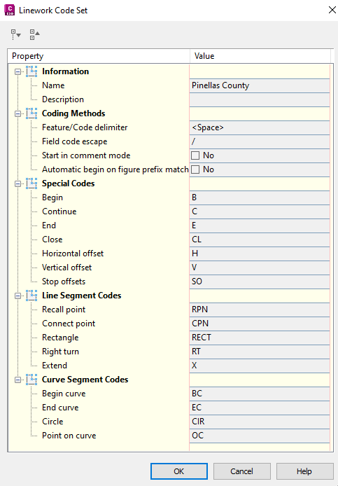

Graphic Symbols

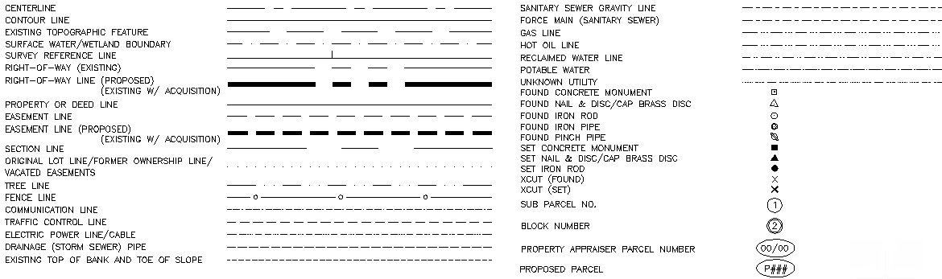

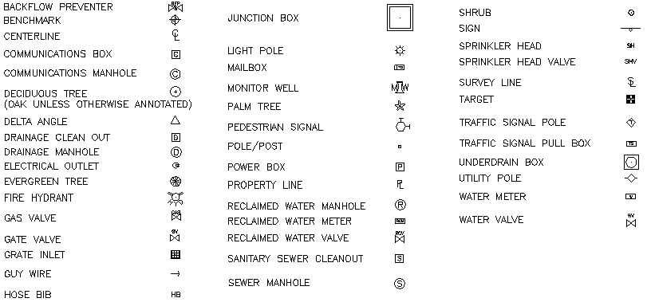

Importing ASCII Files
The ASCII point file is imported directly into Civil 3D to create the point data, figures, and symbology on their designated layer as defined within the PC CADD Standard.
A short video demonstrating how to import ASCII files can be found here

Alignments
Alignments are used as a graphical reference for locating and identifying existing features horizontally along a linear path through the surveyed site.

Standard Alignments

Standard alignments will be drawn from the West to the East and from the South to the North along the survey site. All standard survey alignments will be given the acronym SRL for survey reference line and an explicit description given in the description dialog box of the alignment represented. Additional standard alignments will be numbered accordingly. PC design settings are displayed below:

Example: SRL1, 2, 3, etc.

Alignment Stationing and Labeling

To control how stations appear in Civil 3D, alignment label sets have been created and included with the main PC2025.dwt drawing template. These styles have been created to control the aesthetics of the labels including layer, font, increment, text height, and precision.

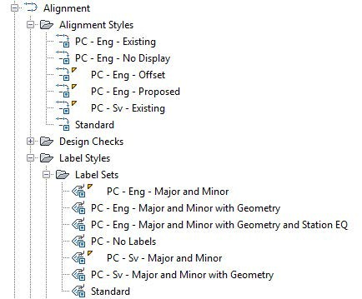

Digital Terrain Models (Surfaces)
The existing DTM, or surface, will be created using one of the included surface object styles. This will ensure adherence to the PC CADD standard.

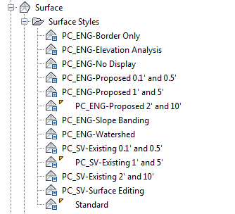

Naming standardization will be based upon the following conventions:

Survey

Surface Name: EG1, EG2, EG3, etc…
Surface Description – Surface description, technician’s initials, original creation date, and modification descriptions to follow the above information.

AS-BUILT

Surface Name: AB1, AB2, AB3, etc…

Surface Description – Surface description, technician’s initials, original creation date, and modification descriptions to follow the above information.

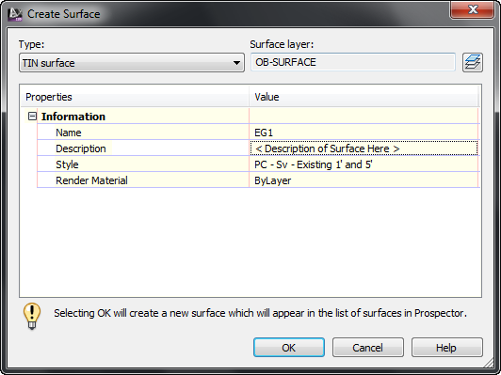

Click here to see a short video on surface creation. Once a surface has been created, it can be easily modified to more accurately reflect real life conditions. Click here to see a short video on surface editing.

Once a surface has been created, any surface labels should use existing styles provided in the PC2025.dwt drawing template. Label styles for contours, slopes, and spot elevations have been provided:

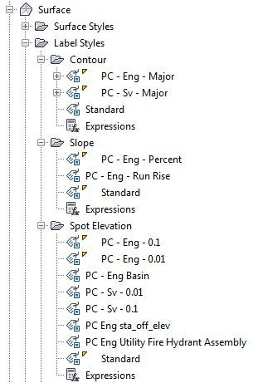

Survey Title Blocks

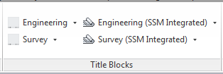

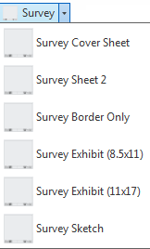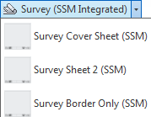

  - Survey Cover Sheet – This is the first sheet of the survey. It includes the Title of Project, Vicinity Map, Pinellas County Map, Graphic Symbols, and Sheet Index.

  - Survey Sheet 2 – This sheet includes the Land Surveyor Report, Abbreviations, Alignments, Monumentation/Control Point Table, and Existing Structure Tables.

  - Survey Border Only – This Title Block is used for the Plan View Sheets.

  - Survey Exhibit (8.5X11) – This Title Block is used for the Exhibits that are created with Sketch and Descriptions.

    - Survey Exhibits (11X17) - This Title Block is used for the Exhibits that are created other than Exhibits for Sketch and Descriptions.

    - Survey Sketch – This Title Block to be used for Sketch and Descriptions.

    - The title blocks with (SSM) as suffixes are Sheet Set Manager integrated. Use these Title Blocks as described above.

Additional Survey Process Information

LDT 2006 to Civil 3D 2014 Project Conversion | A step by step process for converting existing LDT 2006rojects to Civil 3D 2014 projects can be found here.
Alignment Creation | A step by step process for alignment creation can be found here.
Surface Creation | A step by step process for surface creation can be found here.
Pipe Network Creation | A step by step process for pipe network creation can be found here.
Checker Program | A step by step process for the checker program can be found here.
Mapping QC Checklist | The QC checklist can be found here.
Mapping & Transmittal Process | A step by step mapping & transmittal process can be found here.

Note: Some of the processes outlined above are directed towards PC staff and not consultants

Civil Engineering

Points
Project data points consist of existing engineering data gathered from the project location as determined by the project’s PM to assist in the engineering development process. Project data points contain both horizontal and vertical data relative to the chosen coordinate zone – HARN/FL Florida State Plane, West Zone, US Foot. Vertical datum is NAVD 1988.

Points by Range

The point range for PC is specified below:
  - Project Point data – data representative of the project limits as defined by the project’s PM. All PC “Proposed” project point data shall occupy the point range of 100,000 to Infinity.
NOTE: If additional project data points are required prior to survey acquisition, it will be necessary for the PM to specify a NAP, or Next Available Point number.

Point Format
Project data will be represented and contained within a comma-delimited file stored with the project. The desired data point format for the PC standards is as follows:
FIELD ONE --- Point Identifier Number

FIELD TWO --- North Coordinate Value

FIELD THREE --- East Coordinate Value

FIELD FOUR --- Point Elevation

FIELD FIVE --- Point Code Identifier

Point Label Styles
Point Label Styles are used by Engineering to graphically depict data points within Civil 3D. Point Label Styles are defined within the Label Styles collection under Points within the Settings tab of Toolspace. Variations in point label style exist for visual display purposes. The following represents label styles defined in the Civil 3D template:

  - <none>
  - Description Only
  - Elevation and Description
  - Elevation Only
  - Existing Spot Elevation
  - Point Number and Description
  - Point Number and Elevation
  - Point Number Elevation and Description
  - Point Number Only
  - Proposed Northing & Easting
  - Proposed Spot Elevation
  - Standard

Alignments
Alignments are used as a graphical reference for locating and identifying existing plan features horizontally along a linear path through the surveyed site. Station location and elevation along an alignment provide the basis for geometric creation.

Standard Construction Alignments

Standard construction alignments will be drawn from the West to the East and from the South to the North along the survey site. All standard construction alignments will be given the acronym CRL for Construction Reference Line and an explicit description given in the description dialog box of the roadway represented. Additional standard construction alignments will be numbered accordingly. PC design settings are displayed below:

Example: CRL1, 2, 3, etc.

Standard Offset Alignments

Alignments can also be used as to stretch templates horizontally and/or vertically in order to accommodate areas where the roadway offsets or elevations are irregular, such as when a road widens for a passing lane. By using transition regions on a cross section template, you do not need to have multiple templates to accommodate these varying conditions.

Alignment Stationing and Labeling

To control how stations appear in Civil 3D, alignment label sets have been created and included with the main PC2025.dwt drawing template. These styles have been created to control the aesthetics of the labels including layer, font, increment, text height, and precision.

Alignments can be created from a variety of methods including the traditional alignment creation tools as well as from polylines or points.

Digital Terrain Models (Surfaces)
The proposed DTM, or surface, will be created using one of the included surface object styles. This will ensure adherence to the PC CADD standard.

Naming standardization will be based upon the following conventions:

Design

Surface Name: FG 1, FG2, FG3, etc.…
Surface Description – Surface description, technician’s initials, original creation date, and modification descriptions to follow the above information.

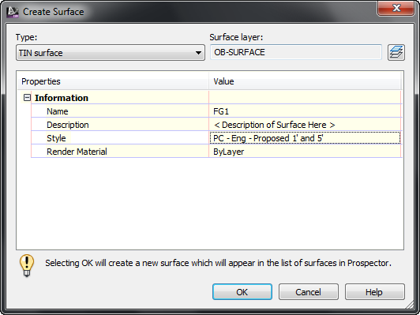

Click here to see a short video on surface creation. Once a surface has been created, it can be easily modified to more accurately reflect real life conditions. Click here to see a short video on surface editing.

Once a surface has been created, any surface labels should use existing styles provided in the PC2025.dwt drawing template. Label styles for contours, slopes, and spot elevations have been provided:

Profiles
Use the profiles commands to create existing ground or finished ground profiles. You can sample a surface to obtain surface data along an alignment from which to generate the existing ground profile. Once sampled, the profile can be displayed according to a variety of styles included in the kit templates.

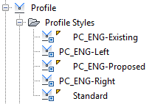

A short video on existing ground profile creation can be seen by clicking here.

Once the existing ground surface profile has been created, proposed profiles can be created in a similar manor as creating alignments. Several profile styles have been included in the kit templates depending on the type of profile represented.

A short video on existing ground profile creation can be seen by clicking here.

Design profiles can be edited easily and in a similar manor as horizontal alignments. A short video on existing ground profile creation can be seen by clicking here.

Profile label styles have been included in the kit templates and should be used when creating profiles. Two profile label sets have been created that will automatically set the correct styles for major station, minor station, grade break, tangent, and vertical curve annotation according to the PC standard.

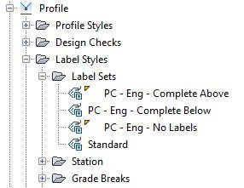

Corridors
Once an alignment and profile exist, the last item to create is an assembly. An assembly is Civil 3D terminology for a cross sectional template. Subassemblies are the building blocks of assemblies. Subassemblies represent lanes, curb, gutter, sidewalks, medians, etc. On top of the several hundred subassemblies that ship with Civil 3D, the PC Kit leverages the custom subassemblies created by the FDOT. To use the FDOT subassemblies, make sure to select the tool palette group named “FDOT Corridors”.

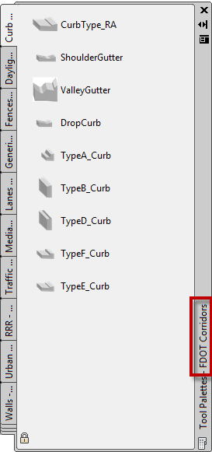

One benefit to creating accurate corridor models is that they can be used to calculate earthwork quantities as well as be displayed in cross sections. To calculate accurate earthwork quantities, accurate surfaces need to be created based on the corridor that represent the top surface and likely a datum (bottom) surface.

To watch a short video on corridor surface creation, click here.

Cross-Sections

Cross-sections in Civil 3D are created from sample lines. The PC Kit uses a width of 75’ on the left and right.

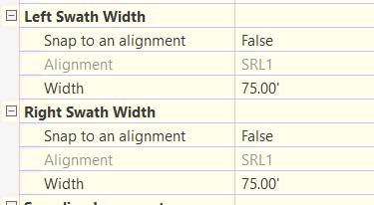

This will create a cross section that will fit one column on each page.

If you are generating earthwork and need to show the cut and fill values, you will need to change these widths to 70’.

If you want to fit two columns on each page, you will need to change these widths to ≤ 30’, depending on how much you need to show.

Pipes
Pipe networks in Civil 3D are made up of structure objects and pipe objects. The PC Kit utilizes the significant investment the FDOT made in the pipe catalogs and links to a copy of the FDOT catalog.
Although the PC Kit templates should automatically point to the PC part catalog, it is good practice to double check prior to creating pipe networks in a drawing.

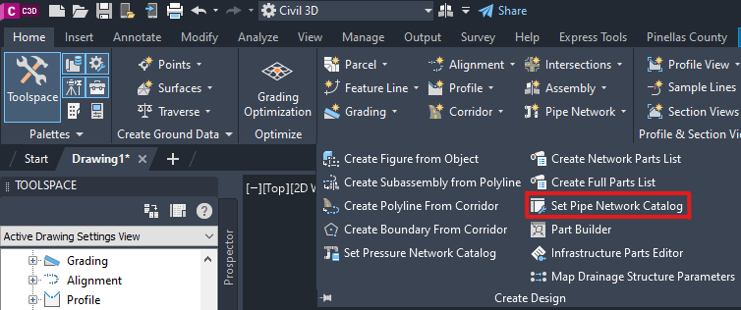

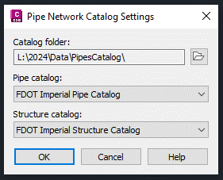

Since Civil 3D only allows for one part catalog to be associated to a drawing at a time, the out of the box parts are not available. However, some out of the box parts are apart of the FDOT Catalogs.
Sample part lists with some of the most common values have been included in the PC Kit template. Part lists for drainage, sanitary, and other utilities have been created to use as a base.

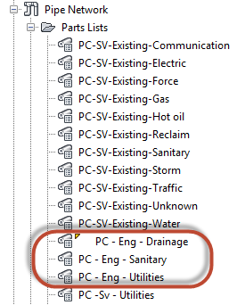It is important to note that parts in the part catalog can be added to these lists at any point in time depending on the design situation. If making edits to the part lists, make sure to completely fill out all the columns including pay item so that quantity take-offs can be run as the design progresses.

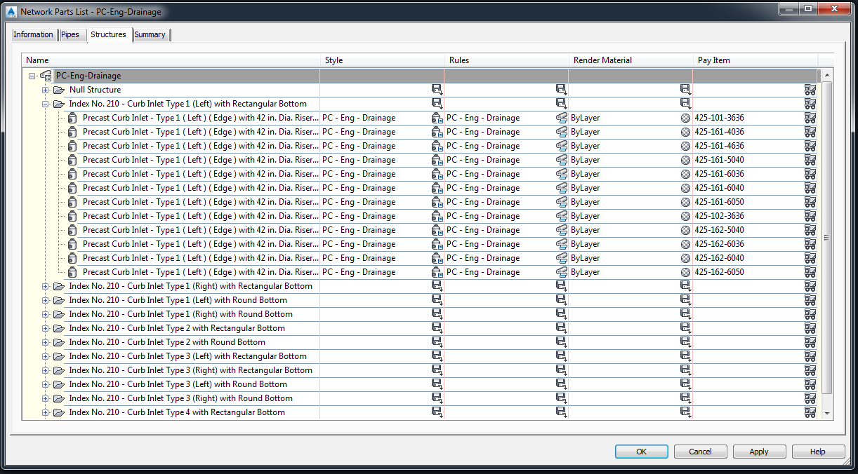

Several videos have been created demonstrating pipes design tasks:

  - To watch a short video on creating pipe networks, click here
  - To watch a short video on adding pipe networks to profiles, click here
  - To watch a short video on adding pipes and structures to existing networks, click here

Plans Production
The plans production tools included in Civil 3D help in the creation of plan only, profile only, plan/profile, and cross section sheets. Included in the PC Kit is a template file that includes predefined layouts for plan/profile and section sheets. The layouts defined in this template include PC title blocks that are sheet set manager integrated.

This template is found at: L:\2025\Support\Templates\PCPlanProduction.dwt

Utilizing the plans production tools in Civil 3D is a straightforward, two-step process:

  - View frames must be created along an alignment that either exists directly in the drawing or is data shortcut into the drawing. For a short video of this process, click here.
  - Once view frames have been created, the plans production routines can be run. For a short video of this process, click here.

Quantity Take-Off
The Quantity Take-Off tools included in Civil 3D help with performing take offs of a given design. Included in the PC Kit is a CSV file that contains the approved pay item codes and descriptions. Although this file has already been associated with the PC template files, it can be found at:

L:\2025\Data\PayItemData\PCStandardPayItems.csv

Also included is a categorization file that will help parse the supplied pay items into manageable categories. This file can be found at:

L:\2025\Data\PayItemData\PCCategories.xml

The main QTO interface is preconfigured to point to PC standard pay items:

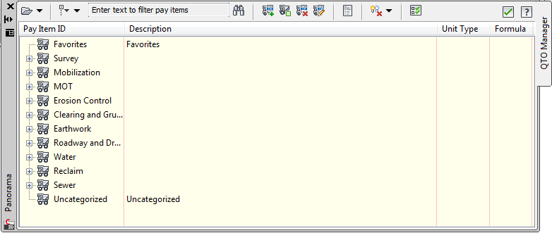

This interface is used for assigning pay item information to existing geometry in a drawing. Part lists for pipes have also been pre-configured with pay item information.

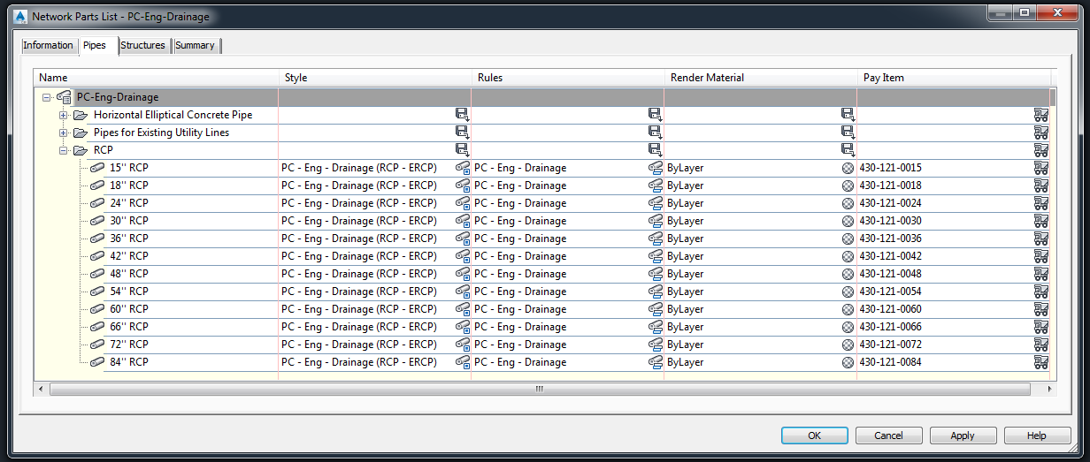

Symbology
The PC Kit includes several drawings containing symbols and typical sections. These files are in the following location:

L:\2025\Data\Libraries

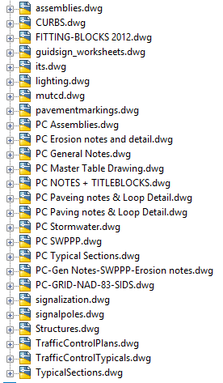

Design Center is intended to be used to access these files and import the appropriate blocks or sections.

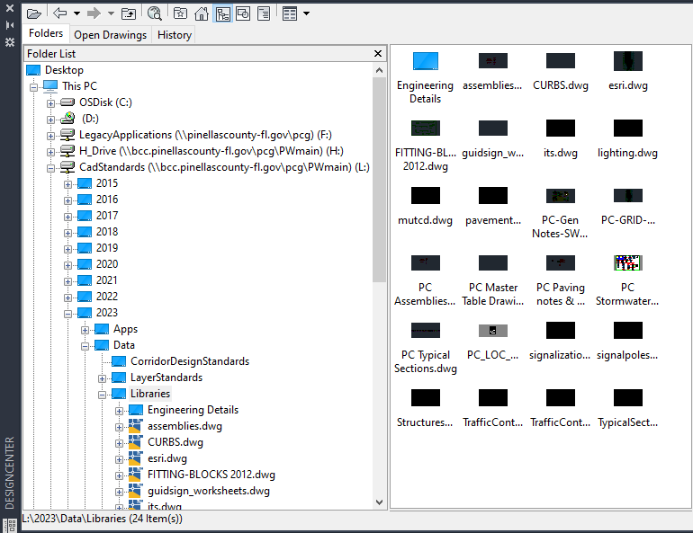

Standard CADD Layers

Layer Prefix and Suffix Descriptions

PREFIX | DESCRIPTION
E- | Existing
P- | Proposed
F- | Future
PS- | PaperSpace / Layout Tabs
X- | External Reference Layers (Xref's)

SUFFIX | DESCRIPTION
-PT | Point - Land Desktop Point Objects
-TX | Text Data
-HT | Hatch Patterns
(none) | Linework & Symbology

Standard Layers

Name | Description
0
0BORD | Title block layer for insertion
CONSTLN | Conceptual construction lines
Defpoints
E-AC | AC slab and equipment
E-AERIAL | Xref data aerial image
E-BDWLK | Boardwalk material
E-BLDG | Building footprint, carports, decks
E-BLDG-OH | Building eaves/overhangs
E-BSHOT | Bottom shot (water, sounding lakes, ponds, etc.)
E-CALC | Calculated field point
E-CL | Centerline
E-COLUMN | Wall/Building columns
E-CONSULT | Consultant xref civil and/or detail services data
E-CTRL | Survey lines
E-DAM | Earth dam or drainage dams
E-DECK | Decks – freestanding or attached to building structures
E-DIM | Dimensions
E-DOCK | All structures over water or beach areas – boat dock, boat ramps, etc.
E-DR | Miscellaneous drainage items
E-DR-BASIN | Drainage Basin
E-DR-DPVMT | Ditch pavement
E-DR-FLOW | Drainage flow line such as ditches, swales, etc.
E-DR-PIPE | Drainage pipes
E-DR-SPIL | Drainage spillway (Body-2)
E-DRW | Driveway line placement
E-ESMT | Roadway or conservation easement
E-FENCE | Fence and fence lines
E-GRAIL | Guard rail
E-GRAVE | Grave or grave sites
E-GWALL | Gravity walls
E-HRAIL | Handrails
E-HWM | High water marks
E-LOTORIG | Original lot line
E-LTD | Lighting devices – spotlight, yard lights, etc.
E-MHW | Mean high water mark
E-MISC | Flag poles, mailbox, testing holes, gym
E-MLW | Mean low water mark
E-MON-FND | Monuments – found – concrete, iron rods, iron pipes, yellow/red caps, pk nail and disk, etc.
E-MON-GPS | Monuments – found – GPS referenced
E-MON-SET | Monuments – set – concrete, iron rods, iron pipes, yellow/red caps, pk nail and disk, etc.
E-MWELL | Monitoring well
E-OHW | Ordinary high-water line
E-OLW | Ordinary low water line
E-OWNER | Feature owner information
E-PEGC | Property line or plat line
E-PLNTR | Planter – concrete or wood structure, etc.
E-PUMP | Small sewer or water pumps
E-RCWM | Reclaimed water main information – designates, fittings, features, etc.
E-RCWM-NETWORK | Reclaimed water main pipe networks
E-RD | Roadway
E-RD-BC | Roadway back of curb
E-RD-BRIDGE | Bridge portion of roadway
E-RD-CNTR | Roadway centerline
E-RD-EP | Asphalt roadway material
E-RIPRAP | Rip rap – drainage control device
E-ROCK | Rock clusters – designed for erosion control, etc.
E-ROW | Right of way line
E-ROW-HATCH | Right of way hatching
E-RR | Railroad
E-SAN | Sanitary sewer
E-SAN-DIP | Sanitary sewer – ductile iron pipe
E-SAN-FM | Sanitary sewer – force main designates
E-SAN-FM-NETWORK | Sanitary sewer – force main pipe networks
E-SAN-GR | Sanitary sewer – gravity line
E-SAN-LIFT | Sanitary sewer – lift station
E-SECT | Section lines
E-SGP | Submerged ground point
E-SHW | Seasonal high-water mark
E-SIGN | Signs of all types number if large billboards with notes
E-SLAB | Concrete slab
E-SLW | Seasonal low water mark
E-SPKL | Sprinkler system
E-STRIPE | Pavement stripes and markings, stop bars, cross walks, lane lines
E-SURV_BOSCO
E-SURV_BURNETT
E-SURV_DUQUE
E-SURV_NOTE
E-SURV_NOTE_AERIAL
E-SURV_PHILLIPS
E-SURV_SHIMP
E-SURV_ZELLER
E-SURVEY-MRKR
E-SURVEY-PT-TBL
E-SW | Sidewalks
E-SWALE | CL of drainage swales
E-SWALL | Seawall structure
E-SWAMP | Swamp line
E-TB | Top of bank – retention/detention areas, lakes, ditches, creeks, etc.
E-TITLE BLK
E-TOPO-BDRY | Surface boundary
E-TOPO-CONT-MAJ | Major contours
E-TOPO-CONT-MIN | Minor contours
E-TOPO-EG
E-TOPO-PNTS | Surface points
E-TOPO-SAMPLE LINE | Cross section sample lines
E-TOPO-SPOT | Spot elevation labels
E-TOPO-TIN | TIN lines
E-TRAF | Traffic devices
E-TRAF-PL | Traffic signal pole, mast arm, mono tube, etc.
E-TRAFCTL | Traffic control devices, flexible delineators, etc.
E-TREE | General trees, tree lines
E-TREE-VEG | Shrub, brush, etc.
E-TS | Toe of slope
E-UT-COMM | Utilities – Communication designates, boxes and vaults
E-UT-COMM-NETWORK | Utilities – Communication pipes networks
E-UT-ELEC | Electrical surface features – designates, guy wires, lights, electrical poles, etc.
E-UT-ELEC-NETWORK | Electrical pipes networks
E-UT-GAS | Gas system – designates, valves and meters
E-UT-GAS-NETWORK | Gas pipe networks
E-UT-HOTOIL | Hot oil line designates
E-UT-HOTOIL-NETWORK | Hot oil line pipe networks
E-UT-LP | Light pole
E-UT-MISC
E-UT-OH | Overhead utility lines
E-UT-PSP | Pedestrian signal pole
E-UT-TANK | Gasoline, diesel tanks (Body-2)
E-UT-TRAFCTL | Traffic control designates
E-UT-TRAFCTL-NETWORK | Traffic control pipe networks
E-UT-UNK | Unknown utility designates
E-UT-UNK-NETWORK | Unknown utility pipe networks
E-UT-UP | Power pole (Body-2)
E-WALL | Wall lines
E-WEIR | Weir data and a drainage structure
E-WETLAND | Wetlands
E-WM | Water main information – sedignates, fittings, features, hosebib, etc.
E-WM-DIP | Water main ductile iron pipe material
E-WM-NETWORK | Water main pipe networks
E-XEG
EX_LN_CONTROL
EX_LN_TB
GSLAYER
HATCH | Hatch
NARROW | North Arrow
OB-ALIGNMENT | Civil 3D object layer: alignments
OB-ASSEMBLY | Civil 3D object layer: assemblies
OB-BUILDING | Civil 3D object layer: buildings
OB-CATCHMENT | Civil 3D object layer: catchments
OB-CORRIDOR | Civil 3D object layer: corridors
OB-FEATURE | Civil 3D object layer: feature lines
OB-FLOWPATH | Civil 3D object layer: flow lines
OB-GENERAL | Civil 3D object layer: general notes
OB-GRADING | Civil 3D object layer: gradings
OB-INTERFERENCE | Civil 3D object layer: pipe interferences
OB-INTERSECTION | Civil 3D object layer: intersections
OB-MASSHAUL | Civil 3D object layer: mass haul diagrams
OB-MATCHLINE | Civil 3D object layer: match lines
OB-MATERIAL | Civil 3D object layer: materials
OB-PARCEL | Civil 3D object layer: parcels
OB-PIPE | Civil 3D object layer: pipes
OB-POINT | Civil 3D object layer: points
OB-PROFILE | Civil 3D object layer: profiles
OB-SAMPLE | Civil 3D object layer: sample lines
OB-SECTION | Civil 3D object layer: sections
OB-SHEET | Civil 3D object layer: sheets
OB-STRUCTURE | Civil 3D object layer: structures
OB-SUBASSEMBLY | Civil 3D object layer: subassemblies
OB-SUPER | Civil 3D object layer: superelevation
OB-SURFACE | Civil 3D object layer: surfaces
OB-SURVEY | Civil 3D object layer: survey
OB-VIEWFRAME | Civil 3D object layer: viewframes
P-ARCH | Architectural drawing data
P-BLDG | Building footprint, carports, decks, finished floor elev
P-BOTT | Bottom of ditch or pond, water body, etc.
P-CAP
P-CL | Centerline
P-CNTR | Centerline
P-CONC | Concrete
P-CONT-MJR | Major contours
P-CONT-MNR | Minor contours
P-DAM | Earth dam or drainage dam
P-DECK | Decks – freestanding or attached to building structures
P-DIM | Dimensions
P-DOCK | All structures over water or beach areas - boat dock, boat ramps, etc.
P-DR | Drainage feature information
P-DR-DIP | Ductile iron pipe
P-DR-ST | Reinforced structures
P-DR-UD | Underdrain
P-DRW | Driveway into parking lots and residences
P-DRW-DIRT | Dirt driveway into parking lots and residences
P-FENCE | Fence and fence line
P-FG | Finish ground
P-GRAIL | Guard rail
P-HANDRAIL | Handrail
P-HOTOIL | Hot oil line
P-LTD | Lighting devices – spotlight, yard lights, etc.
P-MISC | Flag poles, mailbox, testing holes, gym, etc.
P-MWELL | Monitoring well
P-PEGL | Left ground
P-PEGR | Right ground
P-PFGC | Proposed finished ground
P-PFGCT | Proposed finished ground text
P-PIER | Support structures – piers, pier post, etc.
P-PILE | Pilings
P-PL | Property line
P-PLNTR | Planter – concrete or wood structure, etc.
P-POLE | Pole
P-PUMP | Small sewer or water pumps
P-PUMPSTA | Sanitary sewer pump station
P-PVGRID | Profile grid
P-PVGRIDT | Profile grid text
P-RCWM | Reclaimed water main information – pipes, fittings, features, etc.
P-RD-ASPH | Asphalt roadway material
P-RD-BC | Roadway back of curb
P-RD-BRK | Brick roadway material
P-RD-CONC | Concrete roadway material
P-RD-CURB | Curb in roadway system
P-RD-EOP | Roadway edge of pavement
P-RD-EP | Roadway edge of pavement
P-RD-GRVL | Gravel roadway material
P-RD-SHELL | Shell roadway material
P-REBAR | Rebar
P-RIPRAP | Rip rap – drainage control device
P-ROCK | Rock clusters – designed for erosion control, etc.
P-ROW | Right of way line
P-RR | Railroad
P-SAN-FM | Sanitary sewer – force main
P-SAN-GR | Sanitary sewer – gravity line
P-SGP | Submerged ground point
P-SHOULDER | Roadway shoulder
P-SIGN | Signs of all types - number if large billboard with notes
P-SILTFENCE | Silt fence
P-SLAB | Concrete slab, etc.
P-SPKL | Sprinkler system, etc.
P-STRIPE | Pavement stripes
P-STRIPE 2-4 | Pavement stripes – 2 / 4 skip
P-STRIPE 5-15 | Pavement stripes – 5 / 15 skip
P-STRIPE 6-10 | Pavement stripes – 6 / 10 skip
P-STRIPE 10-30 | Pavement stripes – 10 / 30 skip
P-SW | Sidewalks
P-SWALE | CL of drainage swale
P-SWALL | Seawall structure
P-SWAMP | Swamp line
P-TB | Top of bank – retention/detention areas, lakes, ditches, creeks, etc.
P-TOS | Toe of slope
P-TRAF | Traffic devices
P-TRAF-PL | Traffic signal pole, mast arm, mono tube, etc.
P-TRAFCTL | Traffic control devices, flexible delineators, etc.
P-TREE | General trees
P-TREE-VEG | Shrub, bush, etc.
P-TRENCH | Trench
P-TS | Tos of slope
P-TURB
P-UT | Utilities – private utility
P-UT-ATLAS | Utilities from atlas data
P-UT-ATLAS-OH | Utilities – overhead lines from atlas data
P-UT-CATV | Cable TV – private utility
P-UT-CATV_B
P-UT-CATV_OH
P-UT-ELEC | Electrical surface features – guy wires, lights, electrical poles, etc.
P-UT-ELEC-OH | Overhead electric features
P-UT-ELEC_B
P-UT-GAS | Gas system – private utility
P-UT-GAS_B
P-UT-LP | Light pole
P-UT-OH | Overhead utility lines
P-UT-PP | Power pole (Body-2)
P-UT-PSP | Pedestrian signal pole
P-UT-TANK | Gasoline, diesel tanks (Body-2)
P-UT-TEL | Telephone system – private utility
P-UT-TEL_B
P-UT-TEL_OH | Overhead telephone lines
P-UT-UNK | Unknown utility
P-WALL | Wall lines
P-WEIR | Weir data and a drainage structure
P-WM | Water main
P-XFG
P-XGRID | Profile grid
P-XGRIDT | Profile grid text
P-XSSAM | Sample lines
PS-BSCALE | Paper space bar scale
PS-CNOTES | Paper space construction notes
PS-DIGITAL | Digital signature
PS-GNOTES | Paper space general notes
PS-MANUAL | Manual signature
PS-NARROW | Paper space north arrow
PS-SHEET | Paper space sheet manager
PS-TX-L | Standard sheet large text size
PS-TX-M | Standard sheet medium text size
PS-TX-S | Standard sheet small text size
PS-VIEWPORT | Paper space viewport
X-AERIAL | External reference – aerial image
X-ARCH | External reference – architectural data
X-CONSULT | External reference – consultant civil and/or detail services data
X-DESIGN | External reference – civil data
X-GIS | External reference – GIS data
X-OBJECTS | External reference – Miscellaneous object data (MS Word, Excel, OLE)
X-SURVEY | External reference – survey data
X-UT-ATLAS | External reference – utilities from atlas data

Digital Delivery
General

The act of signing, dating, and sealing transmitted plans, specification, reports, or other documents is collectively referred to as signing and sealing.
This policy provides Pinellas County Public Work’s requirements of signing and sealing plans and documents in conformance with Florida Statutes and Florida Administrative Code. The laws and rules referenced in this policy are primarily those governing professional engineers. Other licensed professionals that are required to sign and seal plans or documents are to follow the laws and rules applicable to their profession. 61G15-23.002 Seals Acceptable to the Board. It is the licensee’s responsibility to comply with the signing and sealing requirements applicable to their profession’s laws and rules. It is Public Work’s responsibility to verify that the documents are signed and sealed, and transmitted in accordance with this policy.

Signing and Sealing Contract Plans
The transmitted contract plans Signed and Sealed by the responsible professional(s) become the Record Set. Every sheet of the Record Set must be signed and sealed, except for the following sheets that may be appended to the contract plans set:
- Existing Bridge Plans,
- Developmental Design Standards, and
- Plans that are prepared by an employee of a Utility or other employee exempted under Section 471.003, Florida Statutes, except as follows.
- Utility plans that modify or detail attachments to a bridge or other structure belonging to the Department must Sign and Seal the sheets affecting such bridge or structure.
- Plans prepared by nonexempt parties for a Utility must be Signed and Sealed.
Every sheet of the Record Set must include a title block that contains information for the professional engineer that will Sign and Seal the sheet, showing:
1. The name, address, and license number of the engineer, or
2. If practicing through a duly authorized engineering business, the name and license number of the engineer, and the name, address, and certificate of authorization number of the engineering business, or
3. If employed by a local, State or Federal agency, the name and license number of the engineer, and the name and address of the agency.
A non-engineering licensed professional that will Sign and Seal the sheet must show similar information in the title block related to their profession.

Manual Signing and Sealing
Manual Delivery is the standard practice for Signing and Sealing, and transmittal of contract documents. If you choose to print, sign, and seal final approved plan sheets, each sheet must contain an original engineer/architect signature and seal. Copies of signatures and seals are not acceptable. The requirements for manually Signing and Sealing are covered in the Laws and Rules for each licensee’s profession.

Digital Signing and Sealing
Digital Delivery is a method of electronically transmitting contract documents to Public Works. This includes the creation of Portable Document Format (PDF) files of contract plans and specifications, which are Signed and Sealed with a Digital Signature. Digital certificates used to sign documents submitted to Pinellas County must be acquired from one of the approved digital Certificate Authorities on the website and be of a National Institute of Standards and Technology (NIST) assurance level of three (3) or higher.
Place the following note along the right edge of plan sheets that are digitally Signed and Sealed:
“THE OFFICIAL RECORD OF THIS SHEET IS THE ELECTRONIC FILE DIGITALLY SIGNED AND SEALED UNDER RULE 61G15-23.004, F.A.C.”
The rule number referenced in the note above applies to the engineering professional that is Signing and Sealing the sheet. A non-engineering licensed professional should use the rule number that applies to their profession:
- Surveyors, Rule 5J-17.062, F.A.C.
- Geologists, Rule 61G16-2.005, F.A.C.
- Landscape Architects, Rule 61G10-11.011, F.A.C.
- Architects, Rule 61G1-16.005, F.A.C.
Printed copies of this document are not considered signed and sealed and the signature must be verified on any electronic copies.

Single Digital Signature

Component plans that will be Signed and Sealed by a single professional (signatory) may place a signature block on the component Key Sheet in lieu of using a Signature Sheet. Listing the sheets contained in the PDF to be Signed and Sealed is not required. See Example 1.
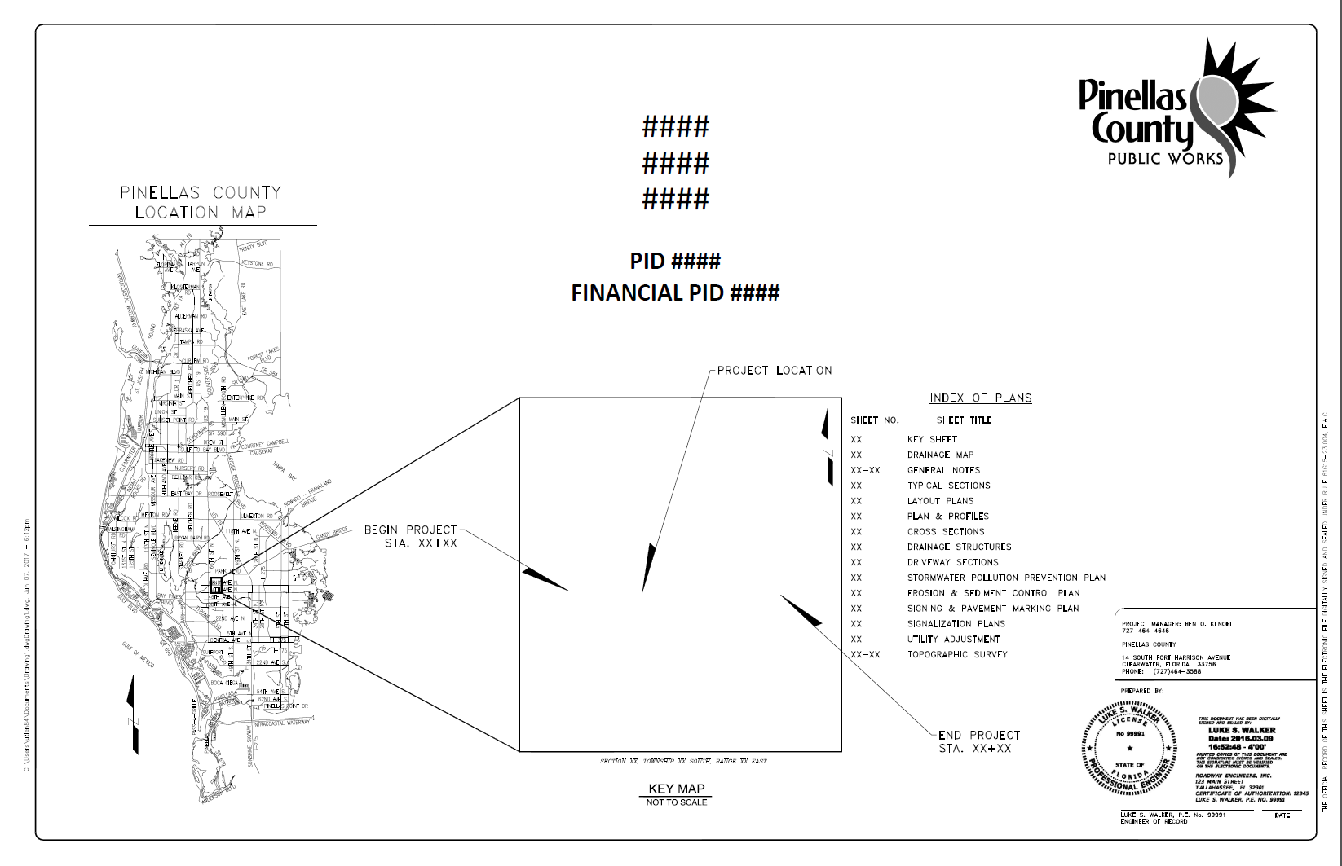
Example 1

Multiple Digital Signature

A Signature Sheet is required for component plans that will be Signed and Sealed by more than one professional. See example 2.
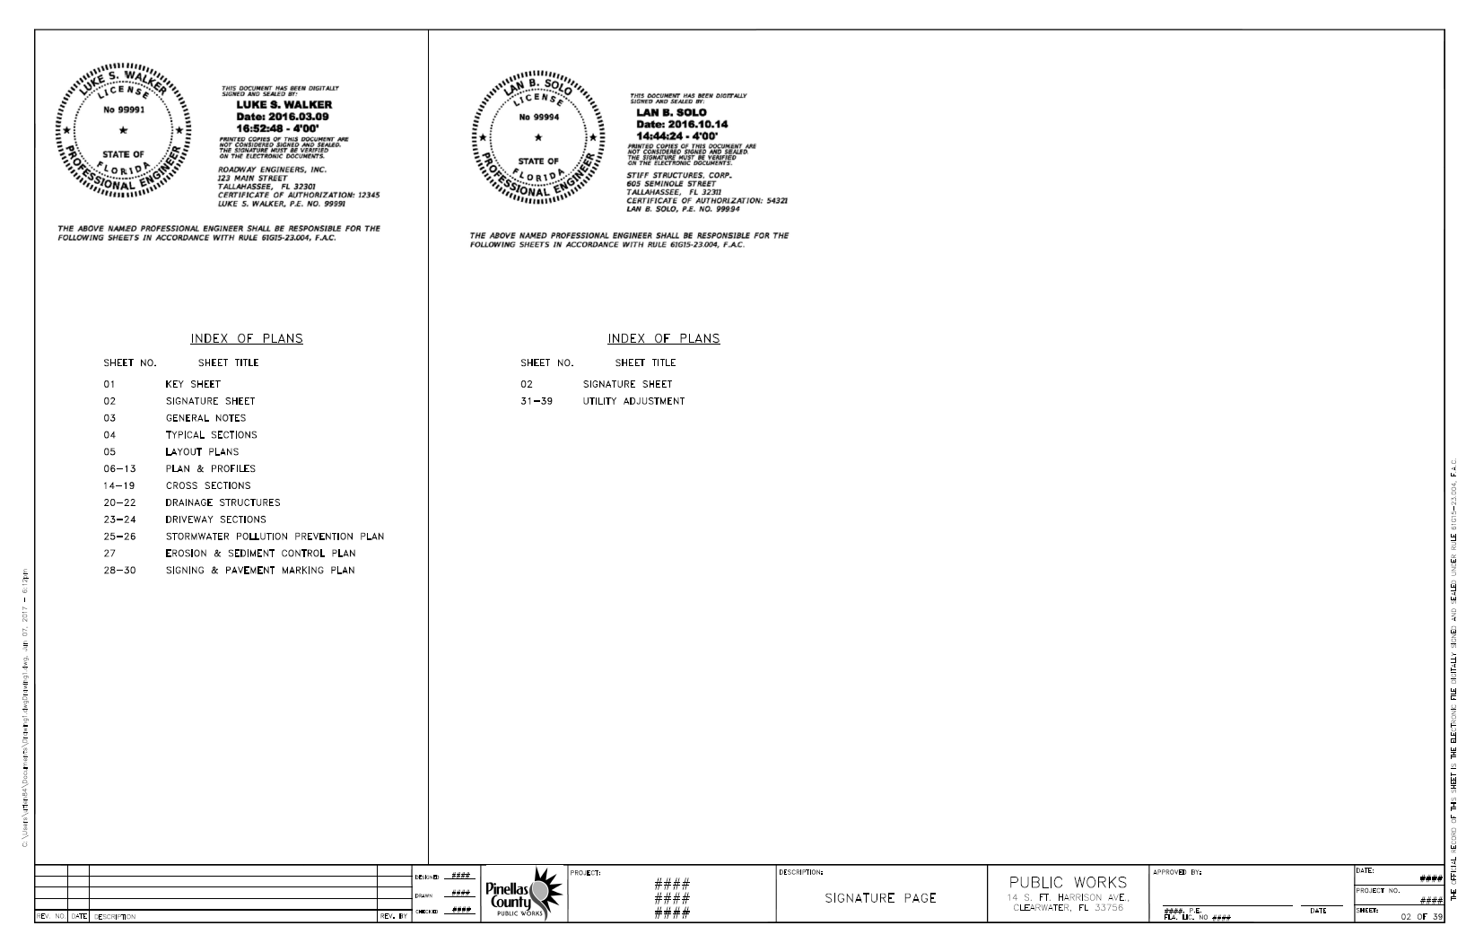Example 2

Signing and Sealing Revisions
Design revisions are modifications to the plans, specifications, and estimate submittal after it has been accepted by Public Works. All revisions should be prepared by the same professional that Signed and Sealed the plan sheet contained in the Record Set or the original document.

Foreign Plan Sheets
In some cases, designers have no choice but to scan pre-existing hardcopy sheets to create digital sheet files. In such cases, those plan sheets should be scanned at minimum of 600 DPI resolution, to PDF. If scanning hardcopy plans that bear a raised seal, then the raised seal should be shaded/burnished before scanning so the seal appears clearly in the scanned image. Scanned existing plan sheets already signed and sealed on paper must not be re-signed and sealed with Digital Signature. However, they may be signed-only (not sealed) by a responsible party only to take accountability for their inclusion within a contemporary plan set (using the appropriate qualifiers or exculpatory language).

